



APTECH Computer Education

* **E-Project of First Semester (ACCP)**
* **Gulistan-e-Jauhar Karachi (Campus)**
* **Sir Meesum Raza (Teacher)**
* **Project duration (15 July 2022-15 August 2022)**

**FLOWCHART**

**CONTACT**

**STORES**

**SITEMAP**

BRANDED

SMART

FOR WOMEN

FOR MEN

VINTAGEE

LUXURY

***FAQs***

***TECHNOLOGY***

***ABOUT US***

***GALLERY***

***PRODUCT***

***HOME***

**CONTENTS**

* **Flowchart…………………………………………….2**
* **Acknowledgement………………………………….4**
* **Preface………………………………………………5**
* **What is this e-Project.……………………………...7**
* **Analysis…………………………………………….8**
* **Introduction…………………………………………9**
* **Homepage………………………………………….11**
* **Product………………………………………………13**
* **Gallery……………………………………………….20**
* **About (contact us) ……………………………………21**
* **About (sitemap)………………………………………22**
* **About (stores)………………………………………….23**
* **Technology…………………………………………….24**
* **FAQs……………………………………………………25**

**SOURCECODE**

* **Homepage……………………………………………26-45**
* **Product………………………………………………46-53**
* **Gallery……………………………………………….54-55**
* **About us(contact)……………………………………56-57**
* **About us(sitemap)……………………………………...58**
* **About us(stores)…………………………………………59**
* **Technology……………………………………………60-62**
* **FAQs………………………………………………….63-64**

**ACKNOWLEDGEMENT**

We are thankful to almighty ALLAH with his grace and mercy for giving us strength and ability to make us complete this e-Project website. We hereby presenting our project on “Alberto Clocks”.

We have tried our best to take all relevant and important topics in consideration so that this project may become more effective & a better outlook to come. This project has been developed with the help of “HTML /CSS / Java Script / Visual Studio Code”.

We earnestly hope that this project will provide all the necessary information required for the user to fulfill their requirement. However, suggestions for improvement of the project will be thankfully acknowledge.

“we achieve this goal with the help and cooperation of our team members”.

**PREFACE**

The thirst for learning, upgrading technical skills and applying the concepts in real

life environment at a fast pace is what the industry demands from IT professionals

today. However busy work schedules, far-flung locations, unavailability of convenient

time-slots pose as major barriers when it comes to applying the concepts into

realism. And hence the need to look out for alternative means of implementation in

the form of laddered approach.

The above truly pose as constraints especially for our students too! With their busy

schedules, it is indeed difficult for our students to keep up with the genuine and

constant need for integrated application which can be seen live especially so in the

field of IT education where technology can change on the spur of a moment. Well,

technology does come to our rescue at such times!!

Keeping the above in mind and in tune with our constant endeavour to use

Technology in our training model, we at Aptech have thought of revolutionizing the

way our students learn and implement the concepts using tools themselves by

providing a live and synchronous eProject learning environment!

**What is this E-Project**

e-Project is a step-by-step learning environment that closely simulates the classroom

and Lab based learning environment into actual implementation. It is a project

implementation at your fingertips!! An electronic, live juncture on the machine that

allows you to

o Practice step by step i.e. laddered approach.

o Build a larger more robust application.

o Usage of certain utilities in applications designed by user.

o Single program to unified code leading to a complete application.

o Learn implementation of concepts in a phased manner.

o Enhance skills and add value.

o Work on real life projects.

o Give a real life scenario and help to create applications more complicated and

useful.

o Mentoring through email support.

**ANALYSIS**

First of all, we would like to thank Almighty ALLAH who gave us mind to think and heart to feel creativity & creation depends on thinking.

“Creativity is Intelligence having fun”

I would like to say thanks to each group member who pays attention and with the help of their contribution **“We made it possible”.**

**“Talent wins games, but teamwork and intelligence win championships.”**

Thanks to our Teacher “Sir Meesum” for his expert advice and brilliant suggestions and always encourage us to do the best.

**“A good teacher can inspire hope, ignite the imagination, and instill a love of learning”**

We would also like to express our deepest gratitude to our parents whose well wishes enabled us to transform our dream into a reality.

**INTRODUCTION**

“Alberto Clocks” is basically an E-project assigned to us by **APTECH** **COMPUTER EDUCATION**. Our team includes five members:

* *Ahmed Fahad.*
* *Muhammad Zaid Sheikh.*
* *Hasan Ali Ahmed.*
* *Syed Ashar Raza.*
* *M.Arsal Meer.*

We all are students of 1st semester of ACCP.

In this project our instructor is **Sir Meesum Raza** who is also our teacher. Due to our efforts and guidance by our teacher we have been able to design a website for “Alberto Clocks”.

Alberto Watch Company is a full-service watch repair, appraisal, and retail store –

offering the finest selection of luxury timepieces. Offering an unparalleled selection

with first-class service.

Alberto also carries a wide selection of brand new watches such as Michael Kors, Rolex, Citizen Eco-Drive, Bulova and more.

You are supposed to create a Single-Page-Application and responsive Website for

them with the below mentioned requirement specifications.

The website is to be developed for the Windows Platform using HTML5, JSON,

Angular JS, JavaScript and Geolocation. The site should work well in all leading

browsers including Chrome, IE, Firefox etc.



**HOMEPAGE**

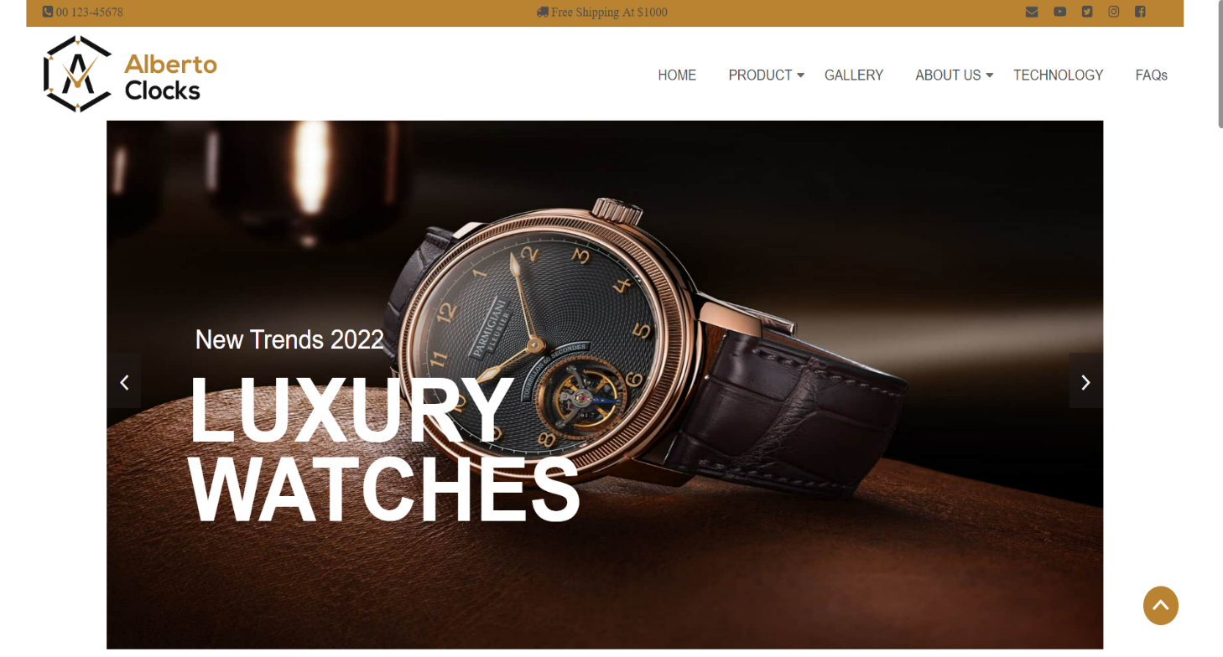

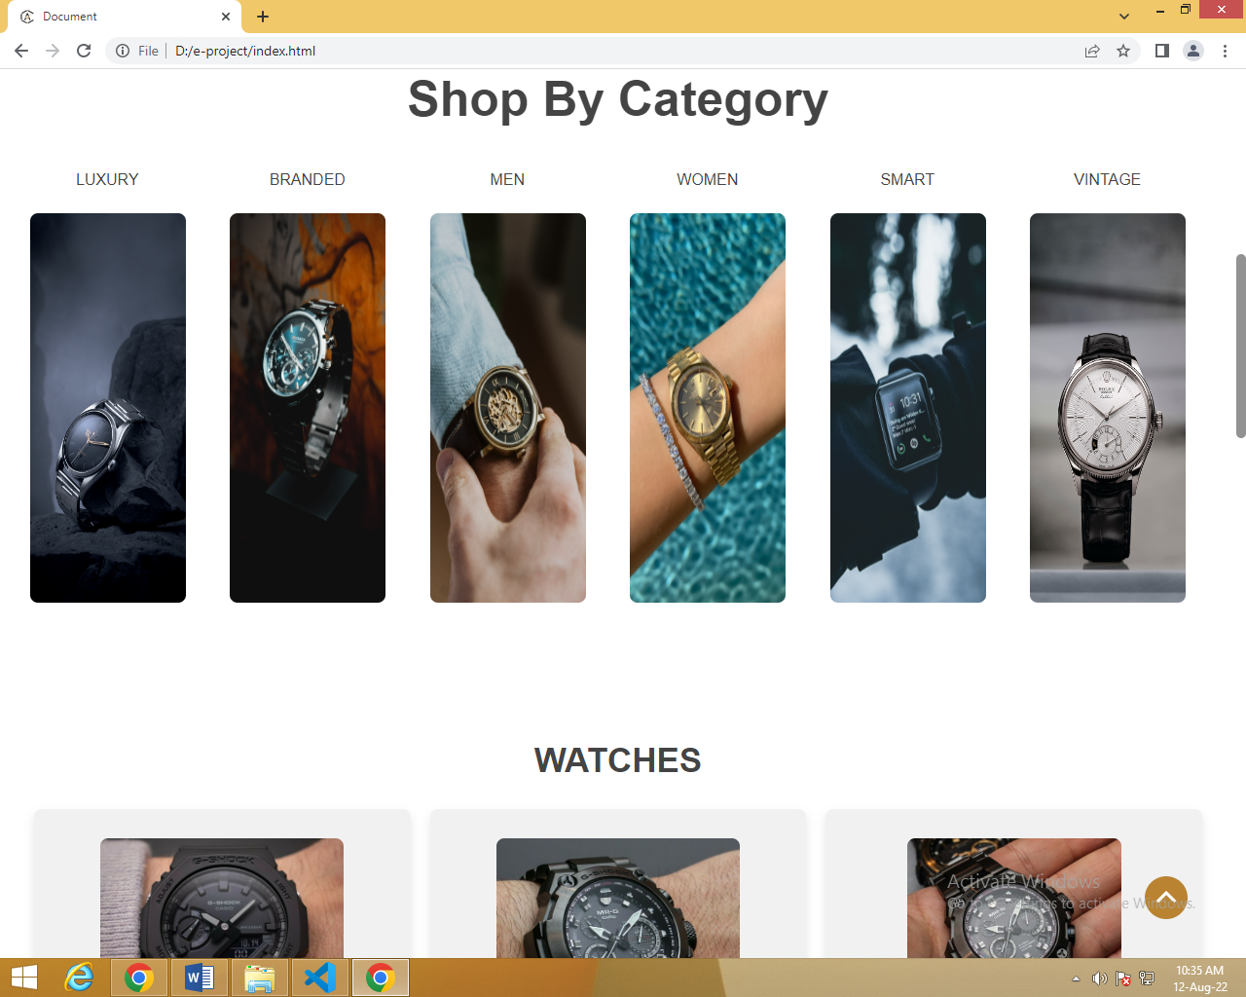

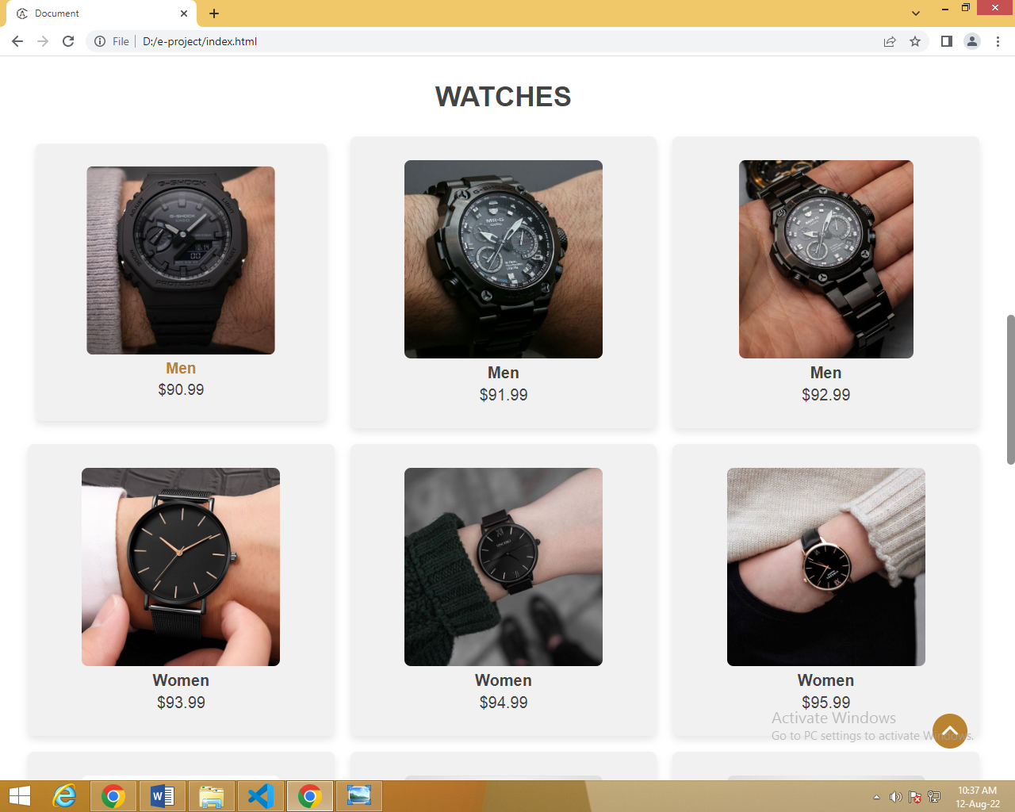

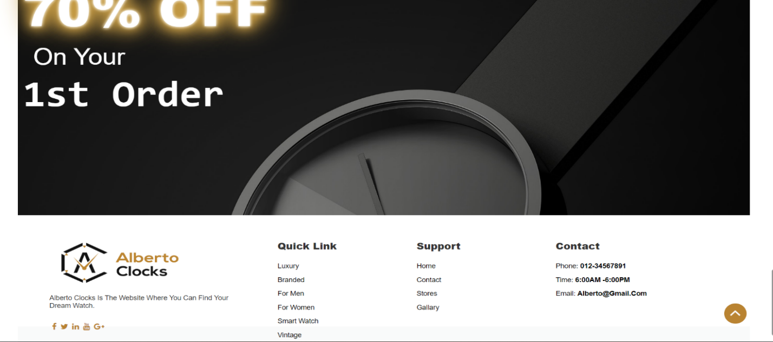

**PRODUCT PAGE**

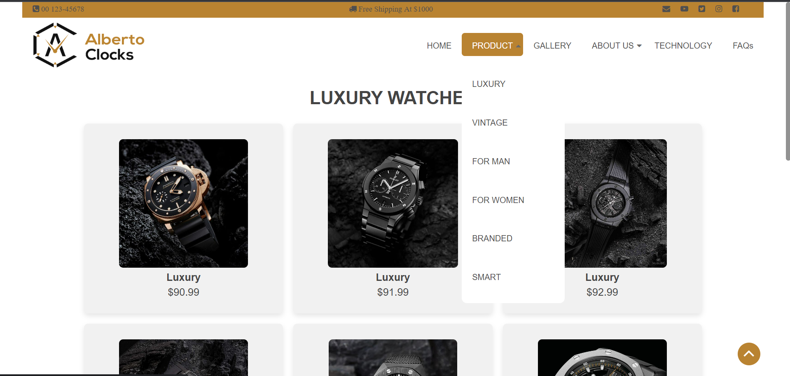

Our product page includes a dropdown with different category of watches with their prices and details on clicking over them.

**LUXURY**



**VINTAGE**

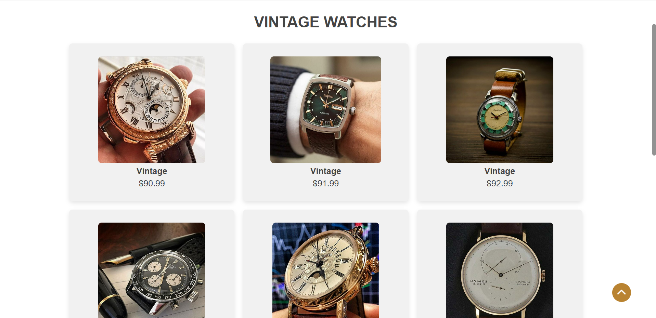

**FOR MEN**

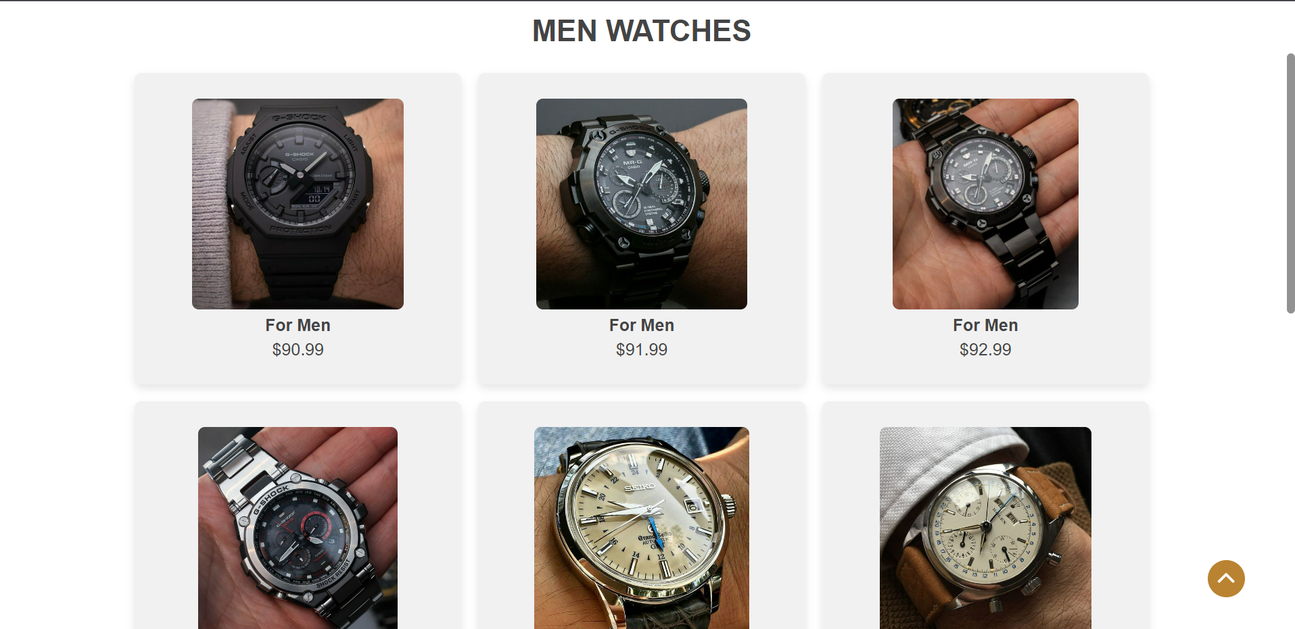

**FOR WOMEN**

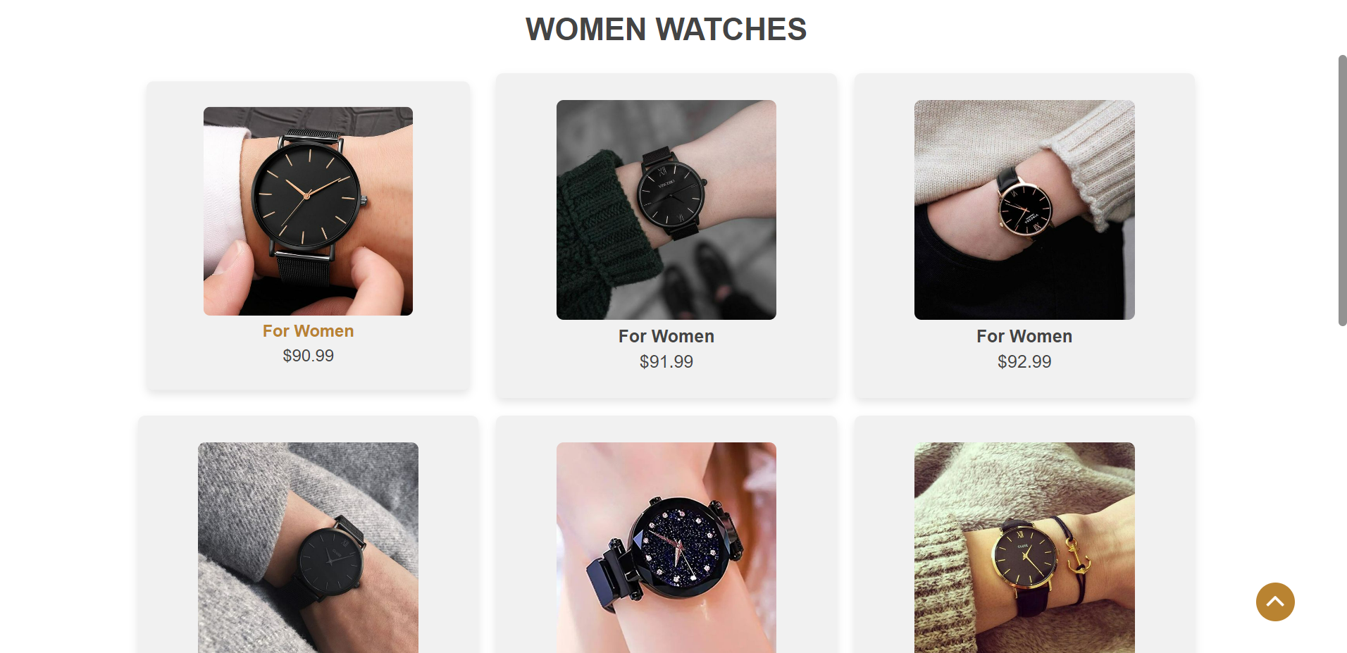

**BRANDED**

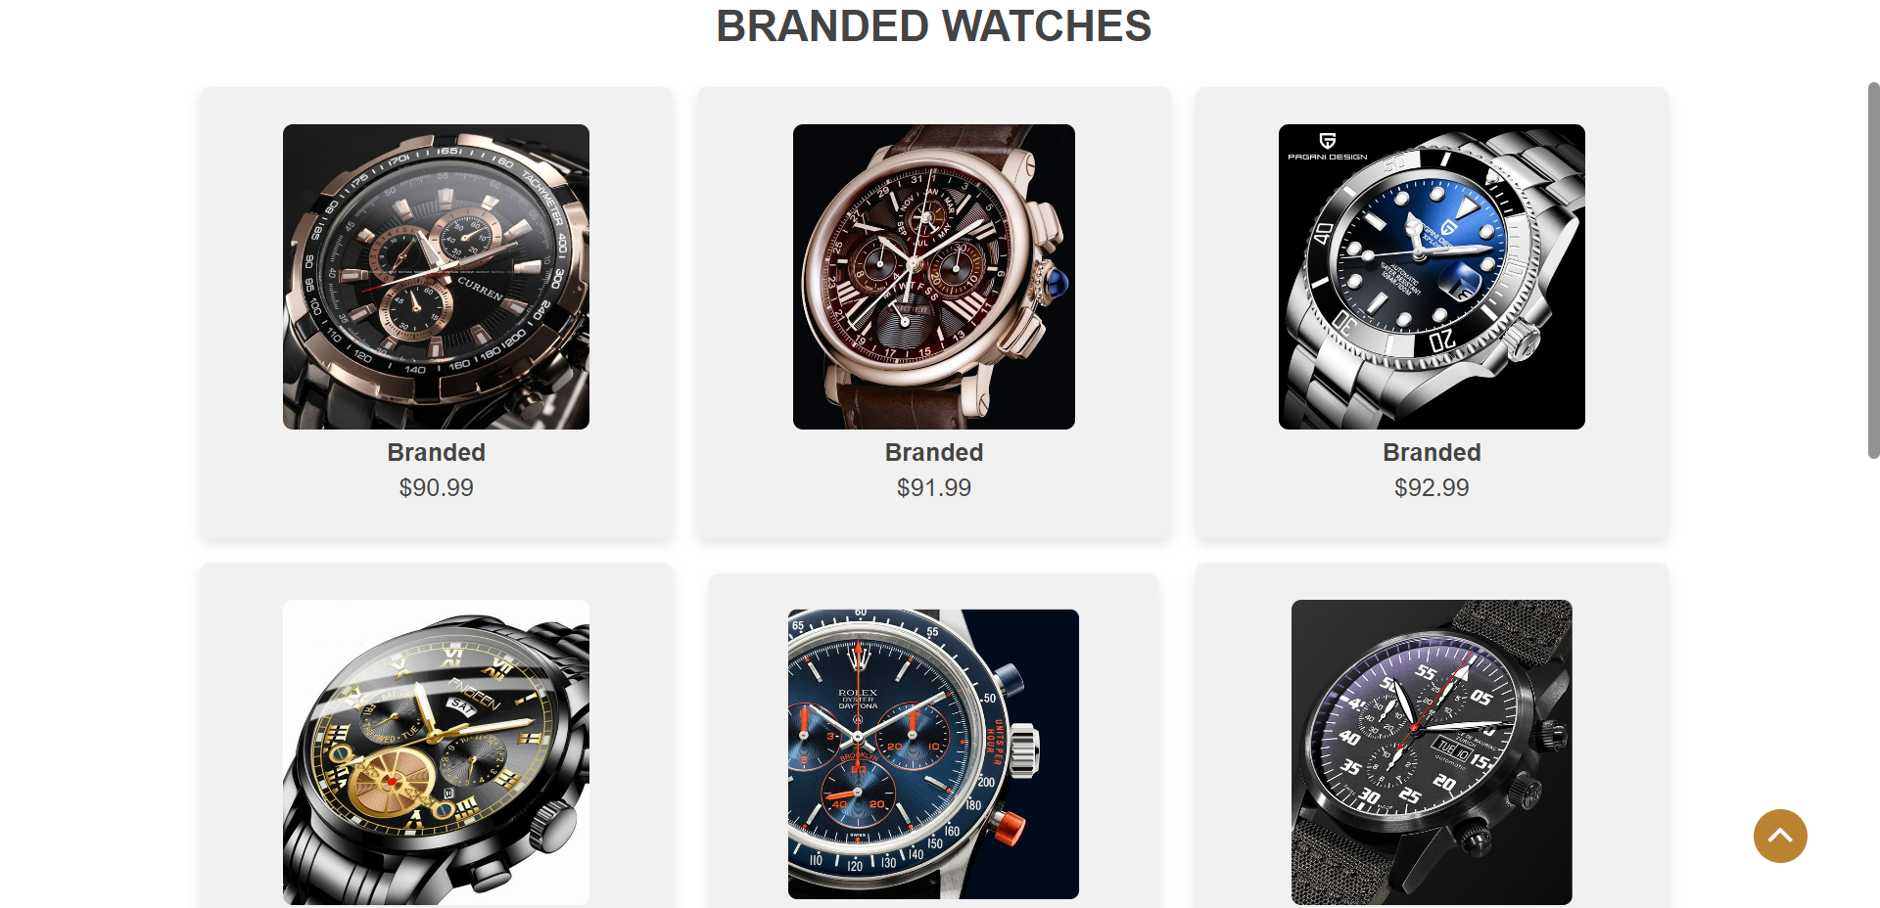

**SMART**

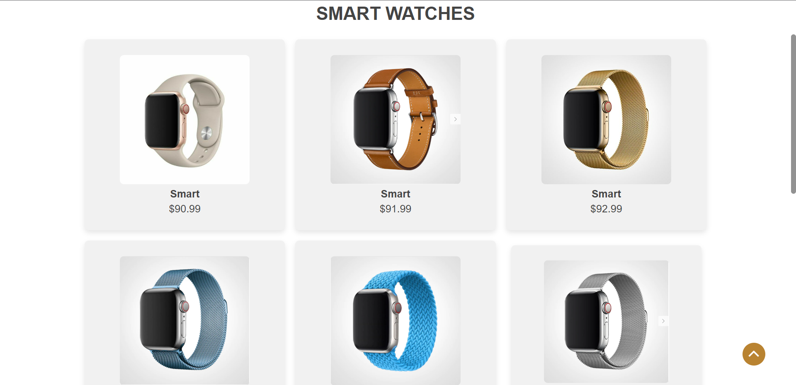

**GALLERY PAGE**

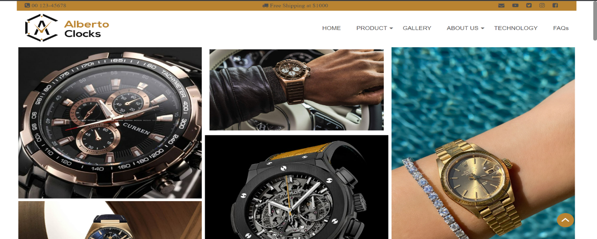

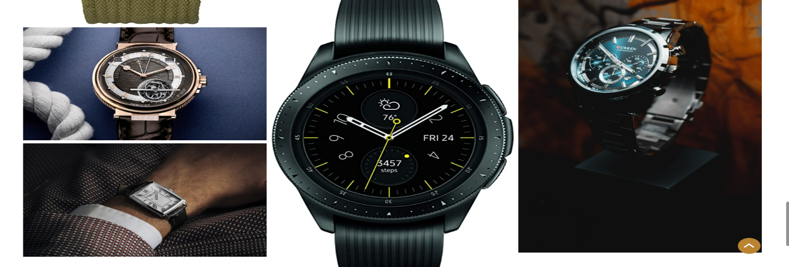

Our Gallery page contains a collection of images related to our products.

**ABOUT PAGE (contact)**

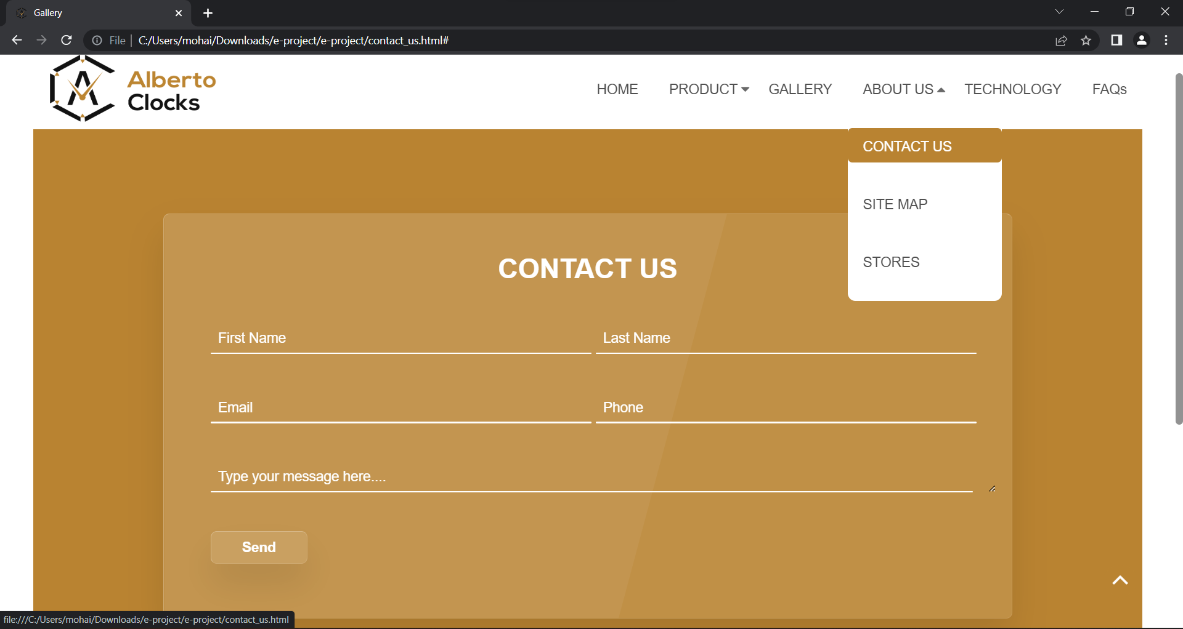

The About us page is displayed along with a dropdown having contact us, sitemap and stores menus.

Contact us includes name, Email, Phone and Message fields.

**ABOUT PAGE (sitemap)**

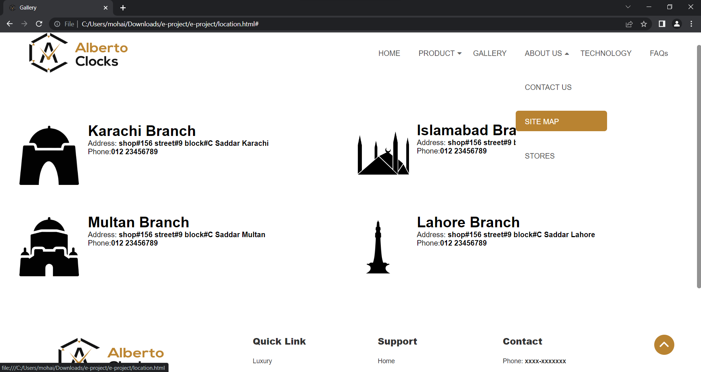

Sitemap is added for our user between the navbar and footer which tells about our branches and their details.

**ABOUT PAGE (stores)**

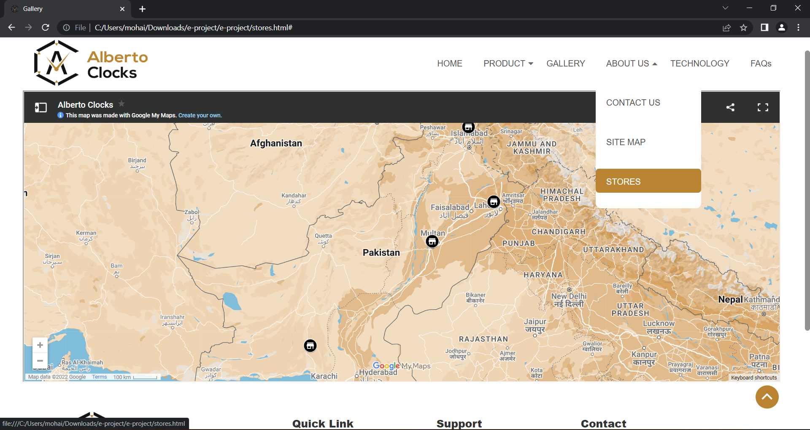

Google map showing the location of our stores all over the country.

**TECHNOLOGY PAGE**

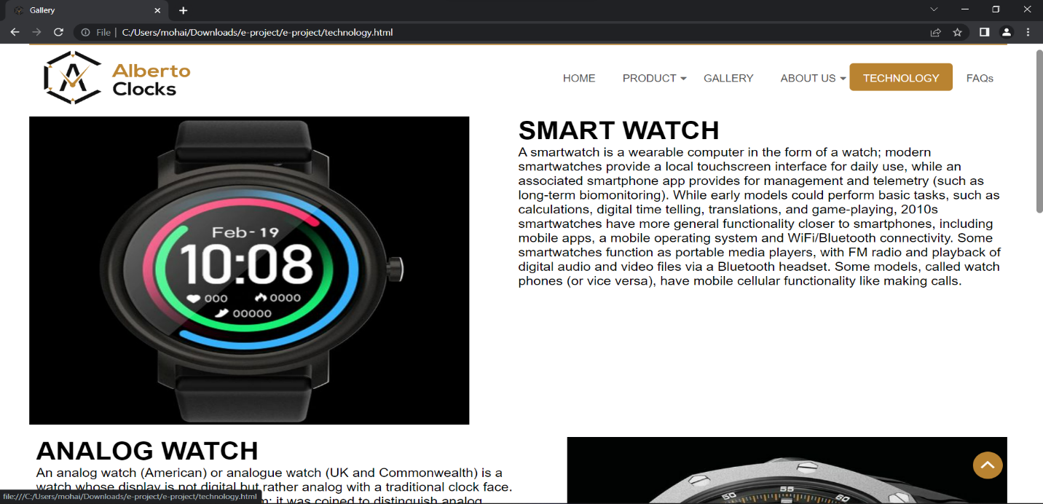

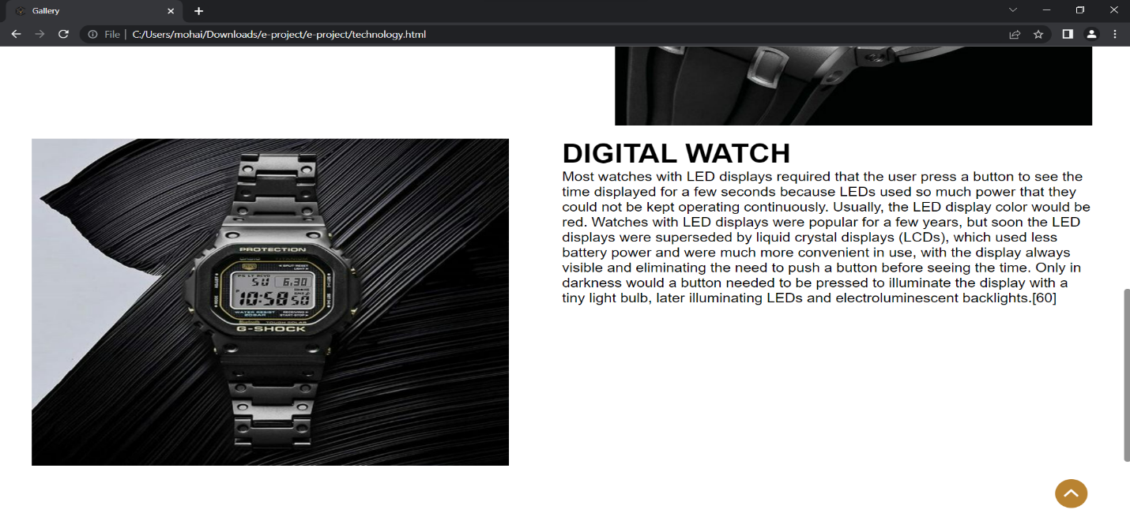

**FAQS PAGE**

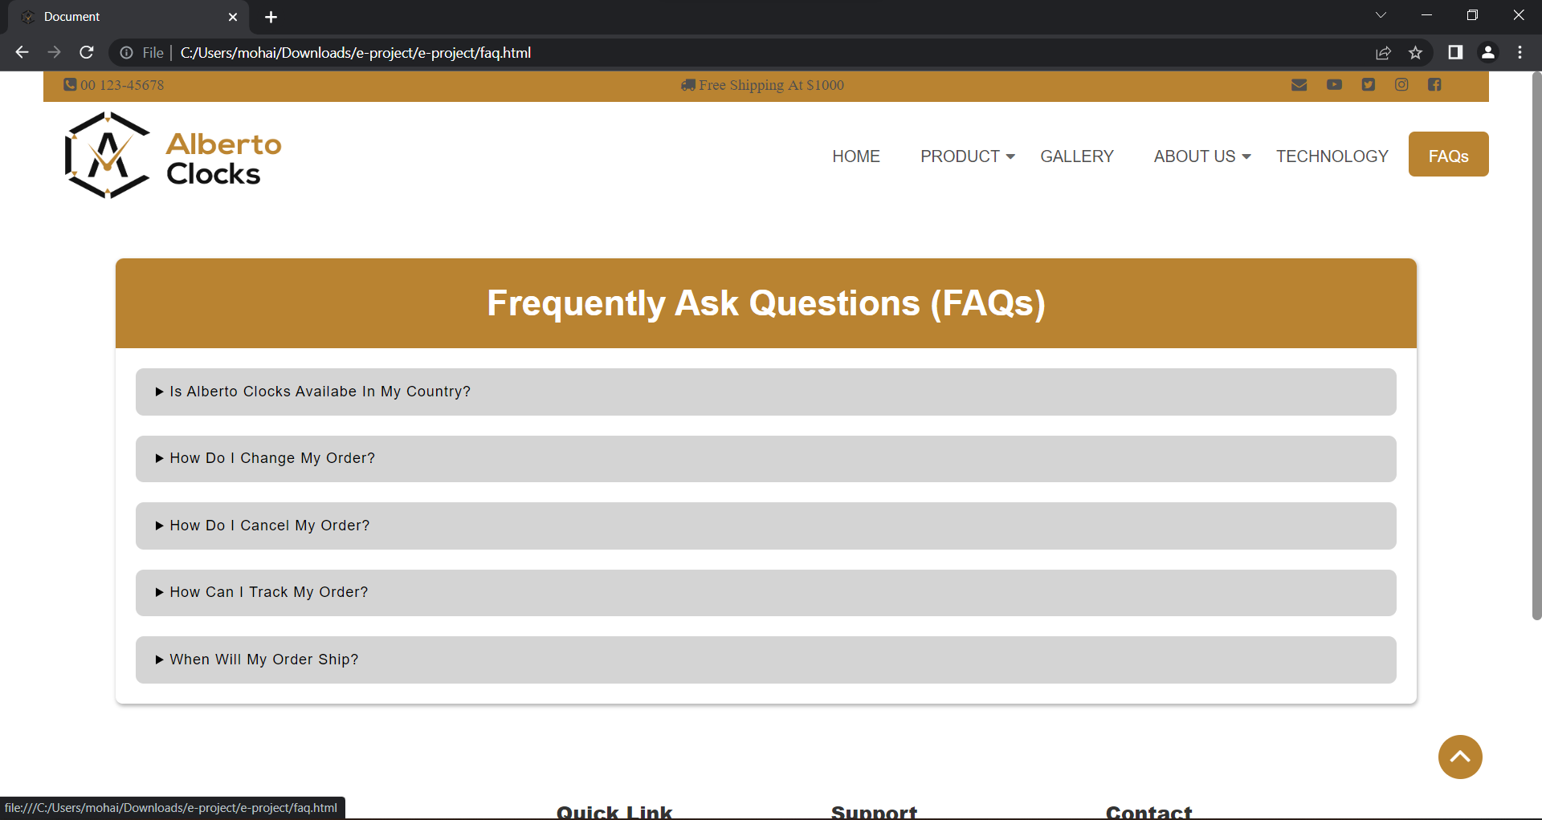

**SOURCECODE (Home)**

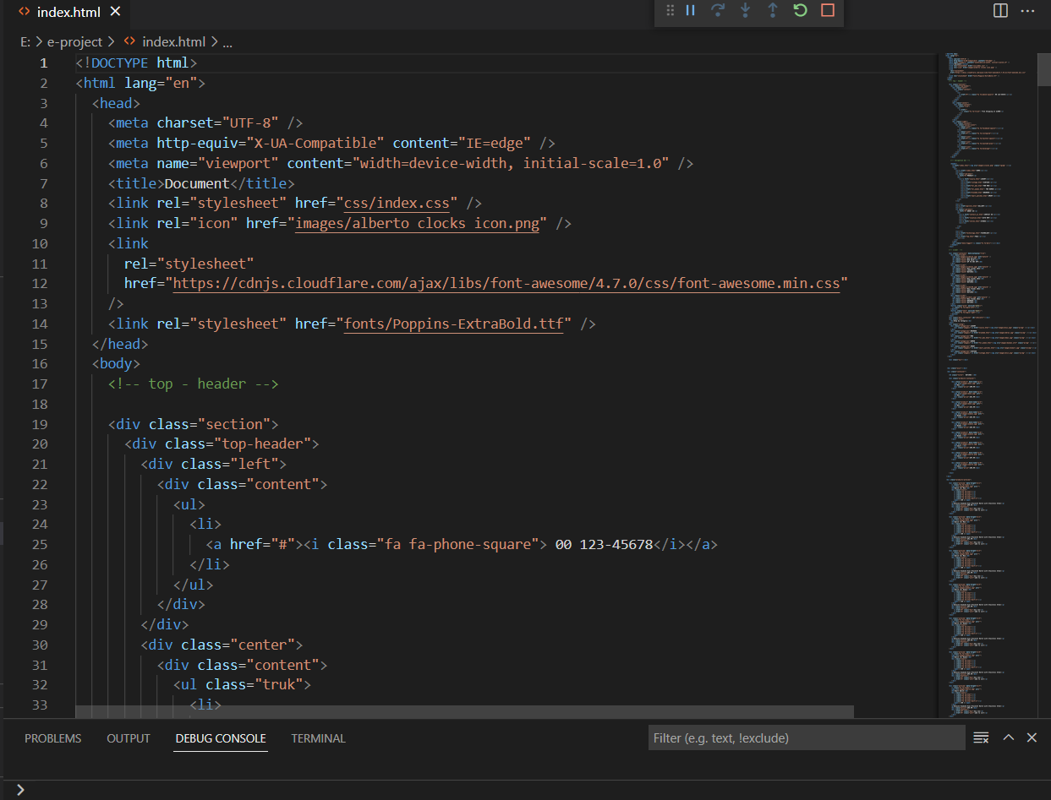

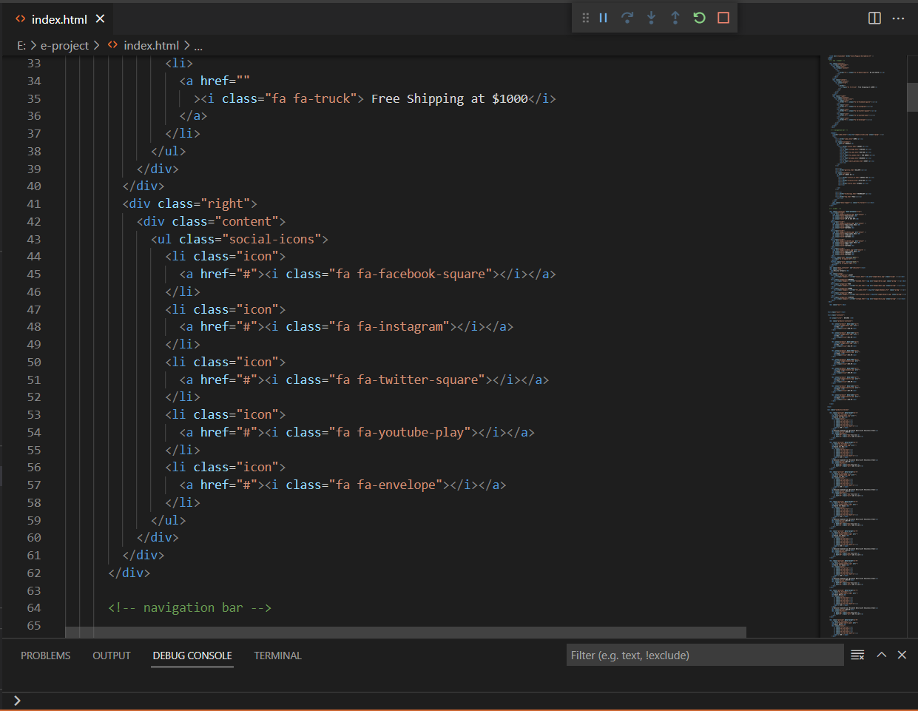

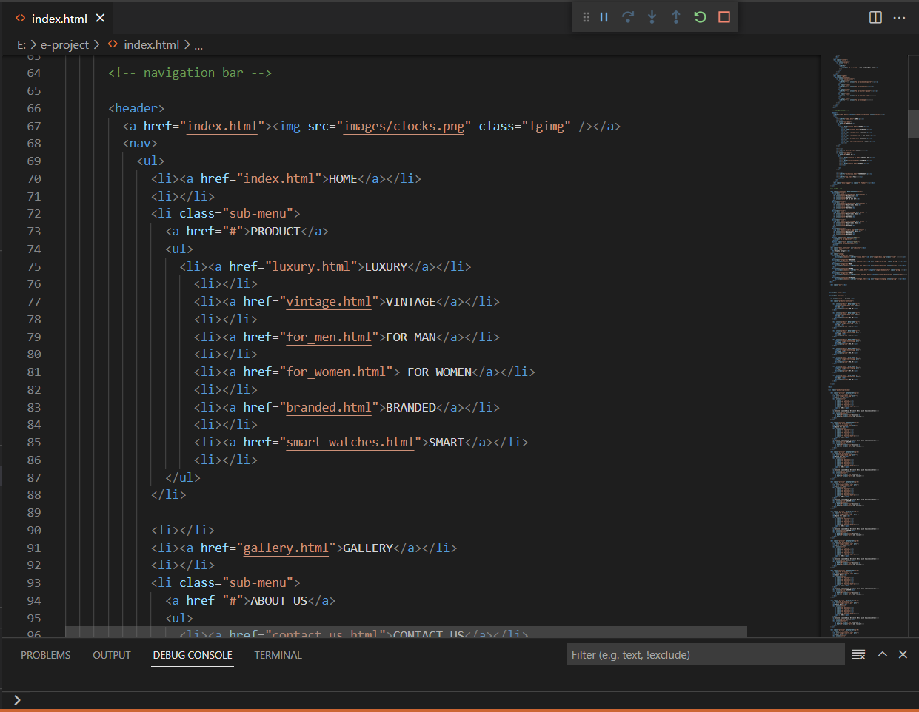

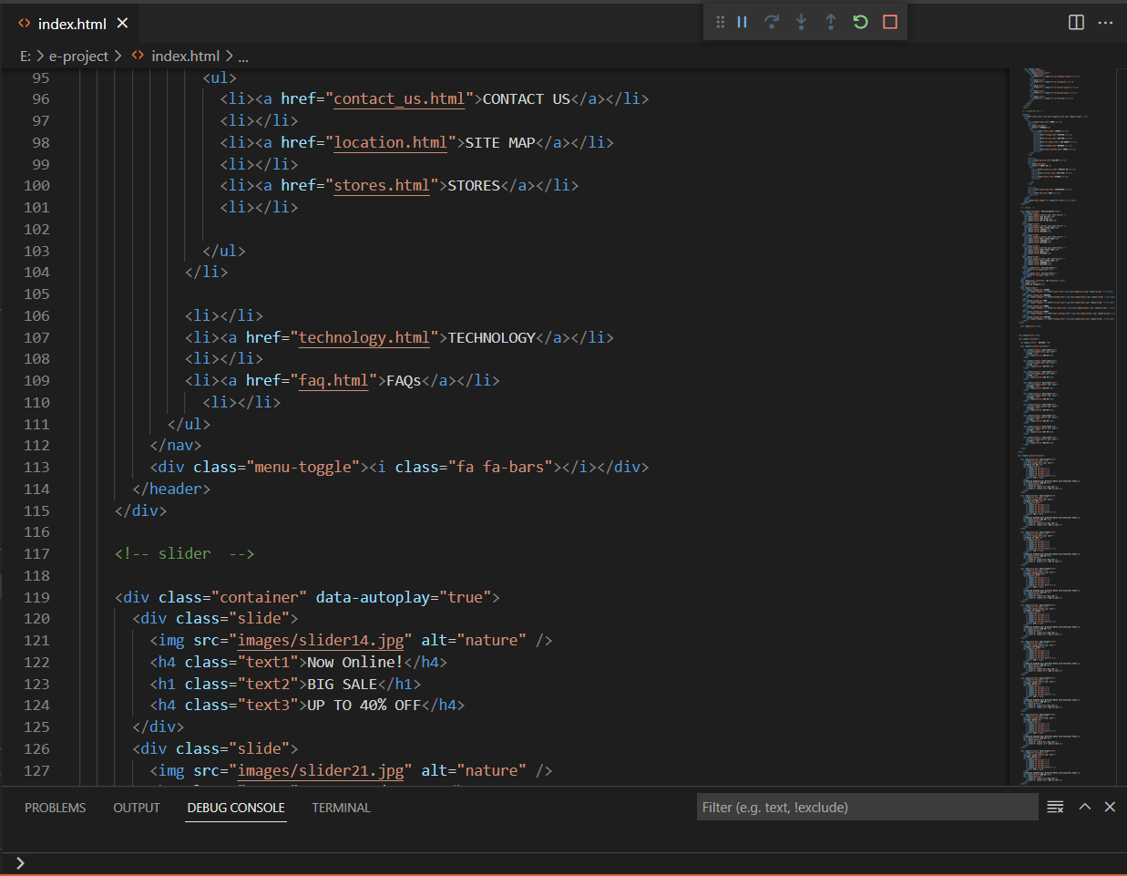

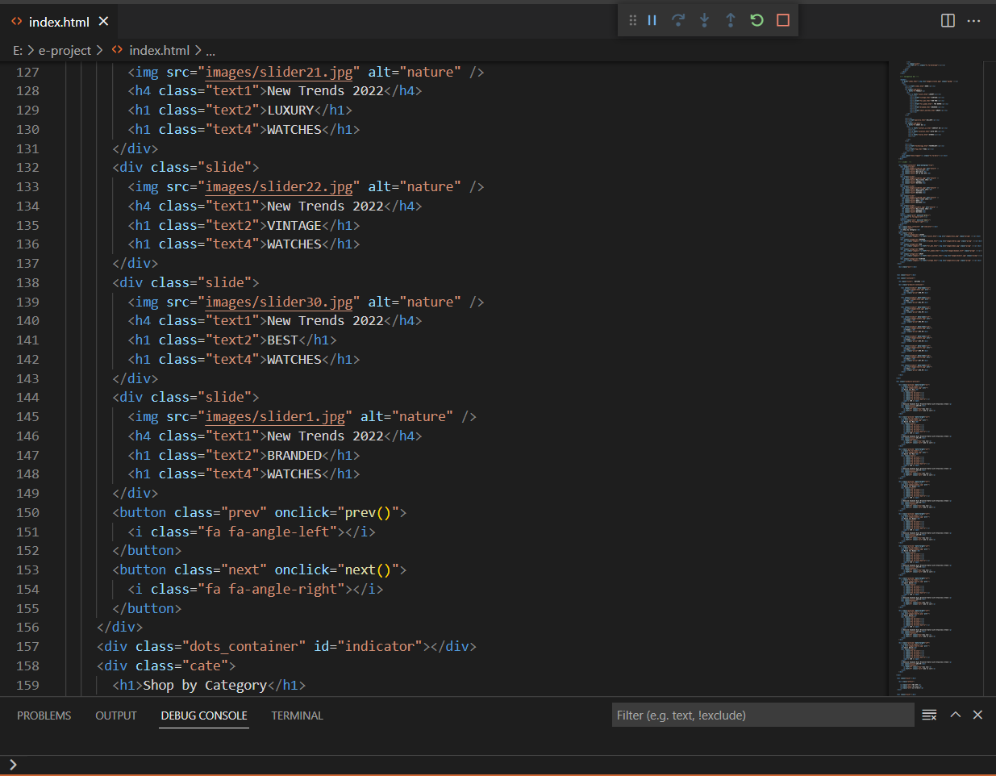

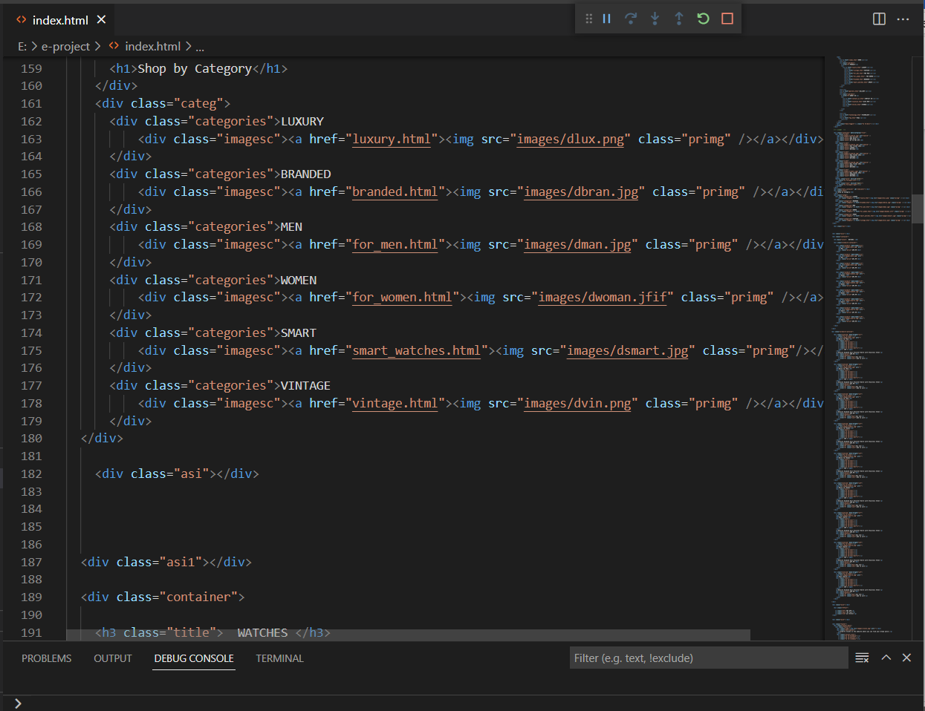

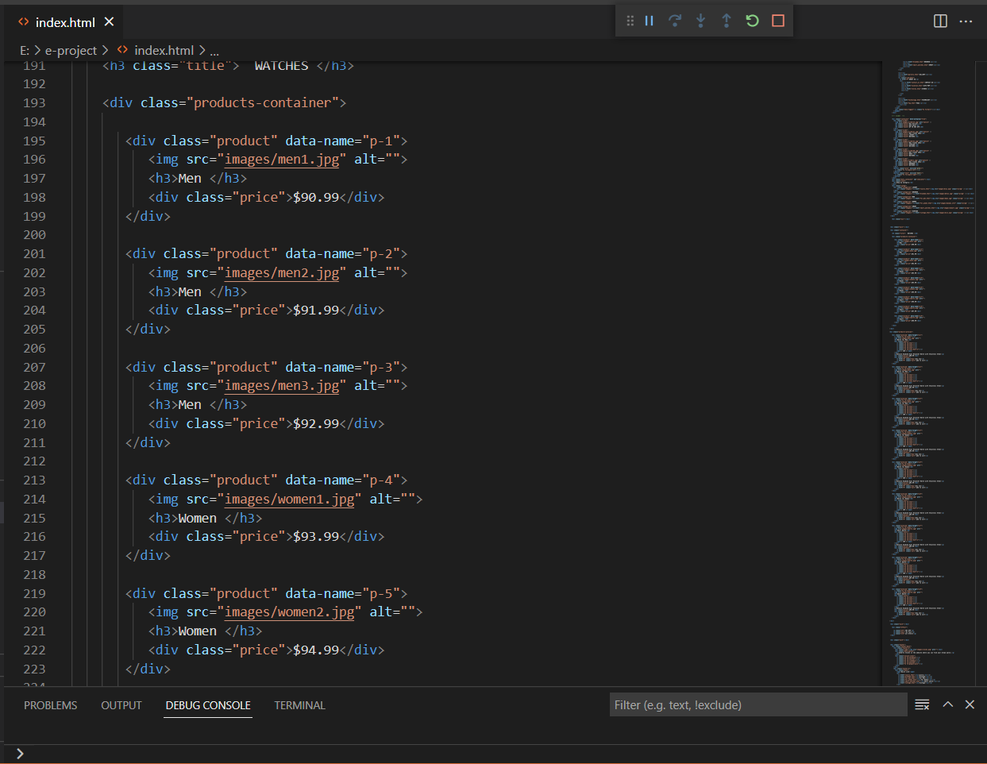

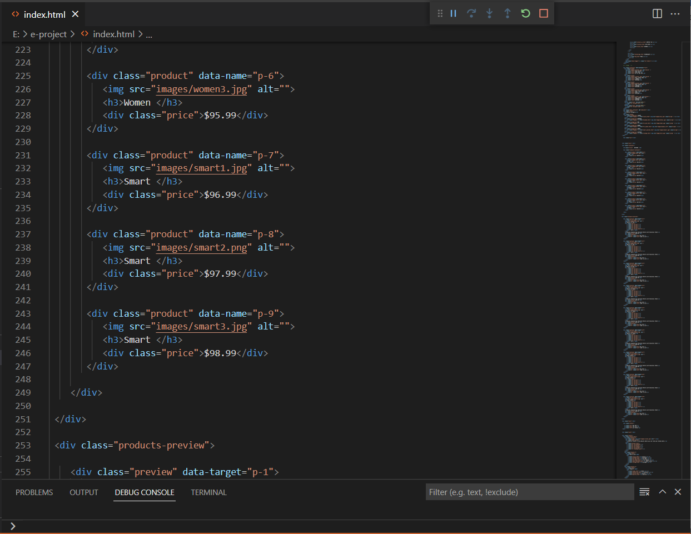

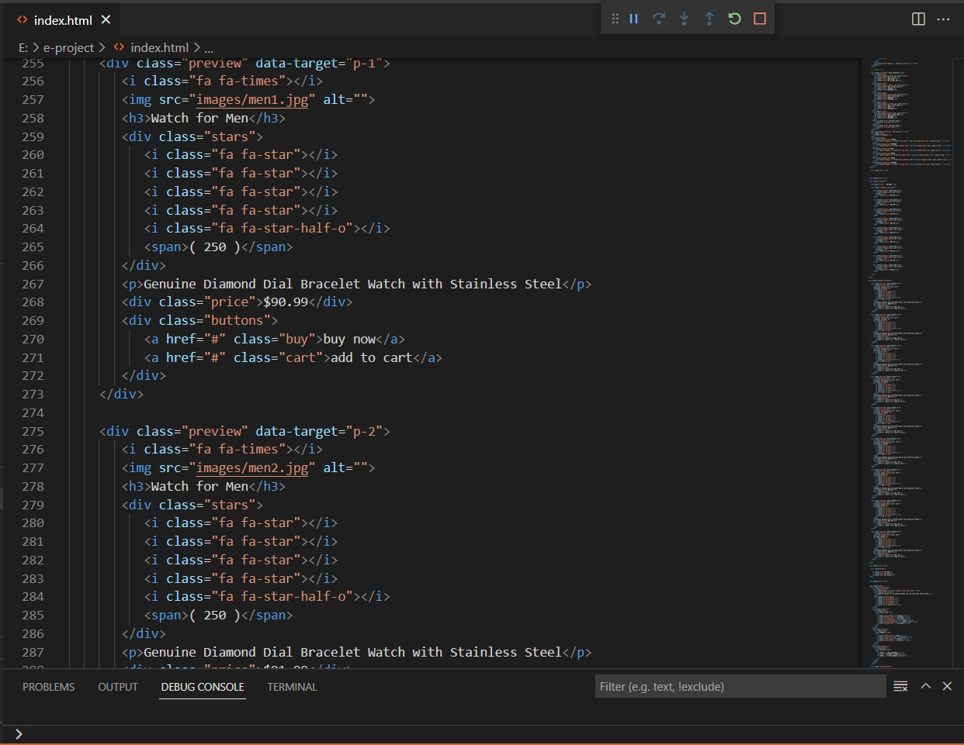

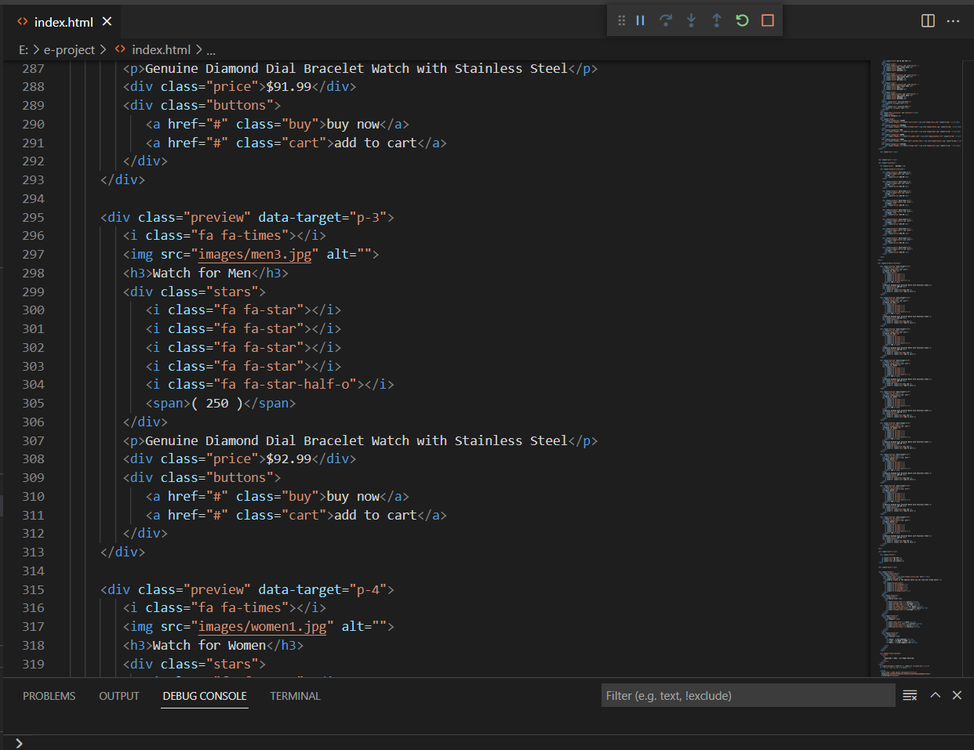

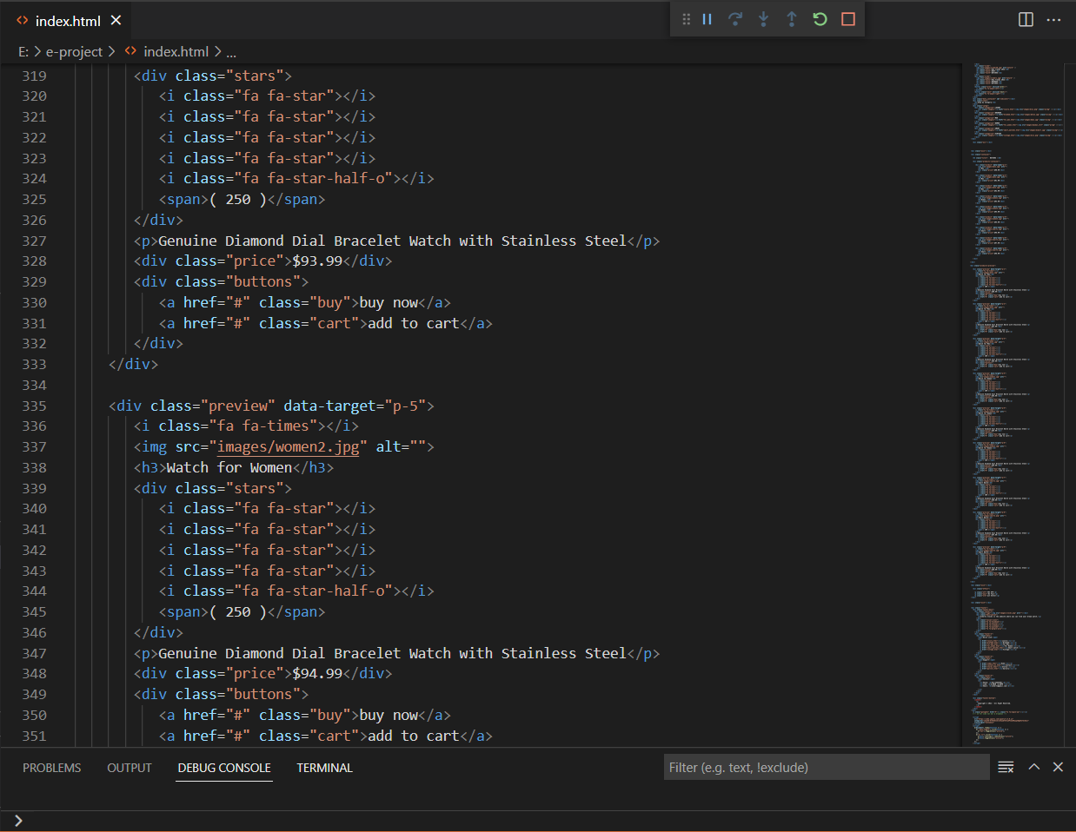

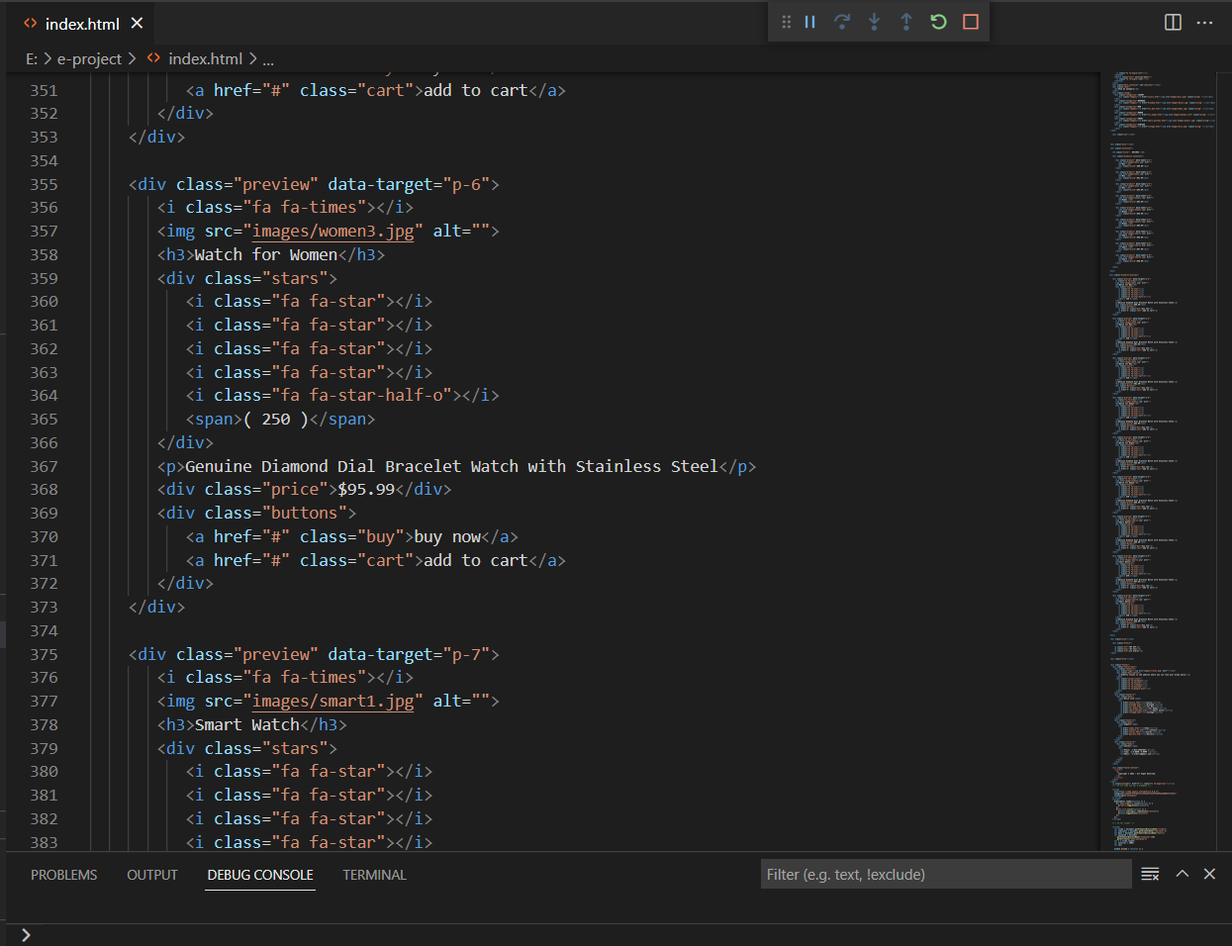

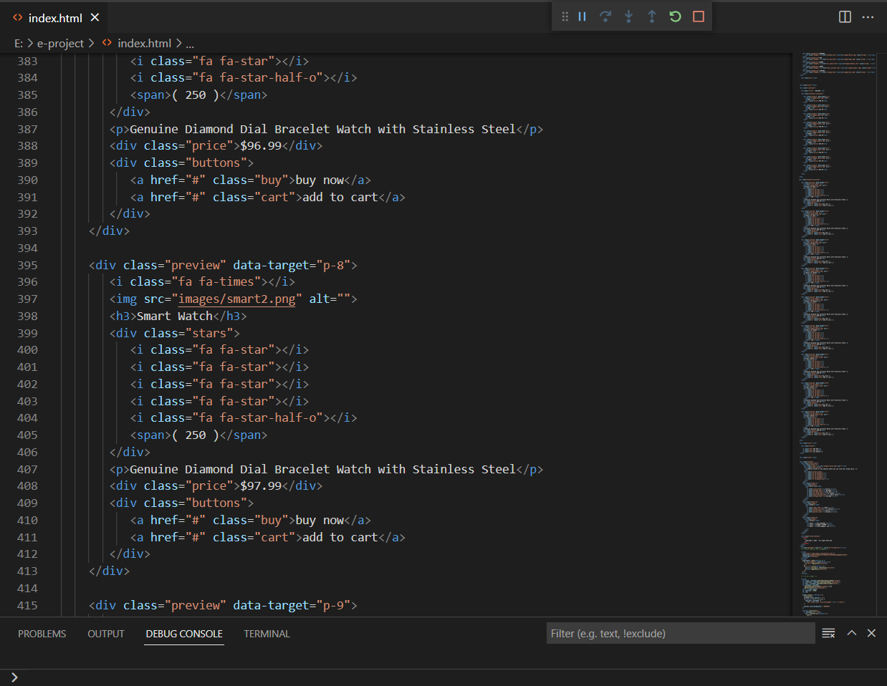

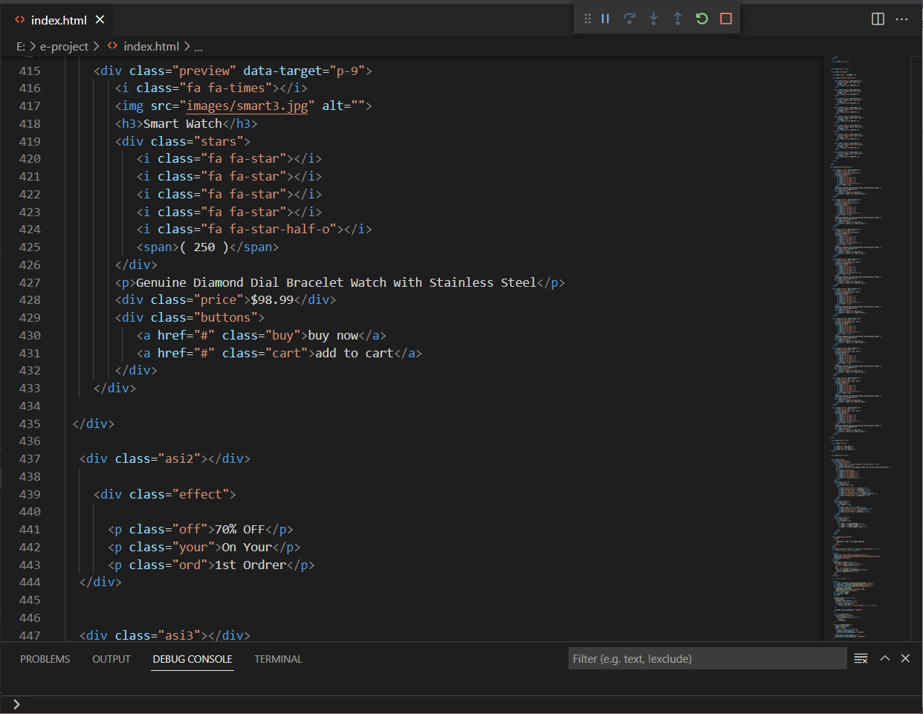

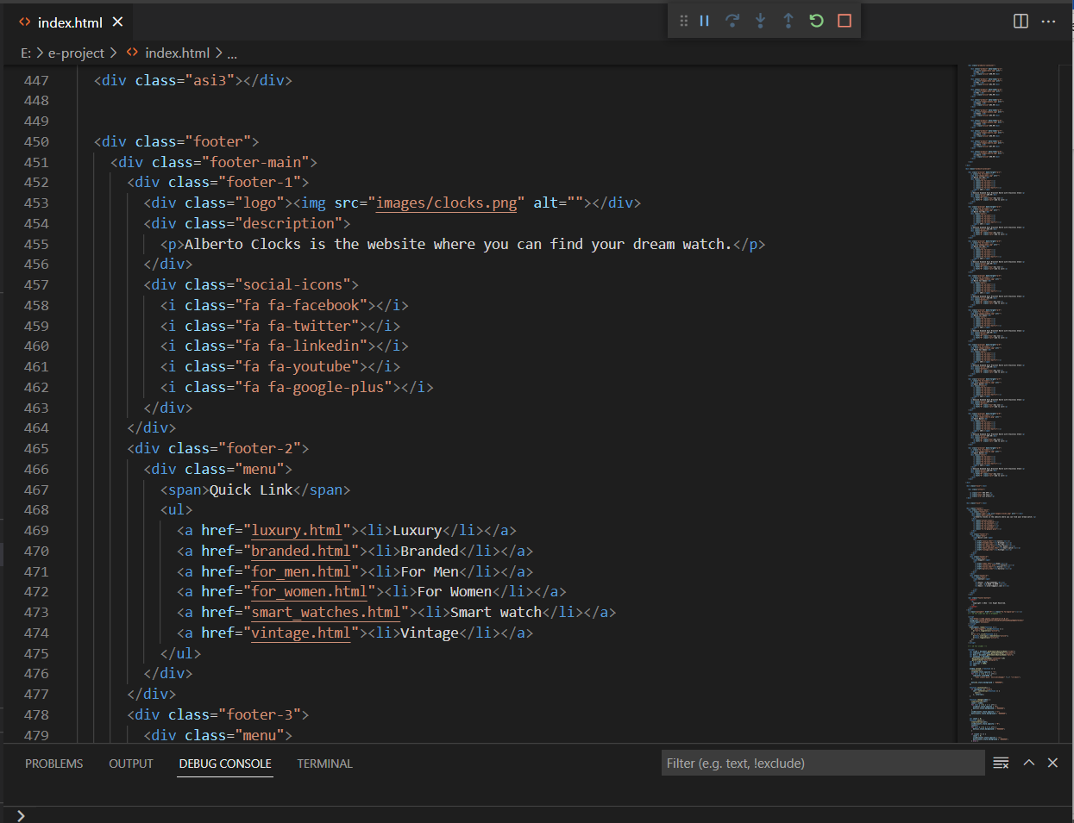

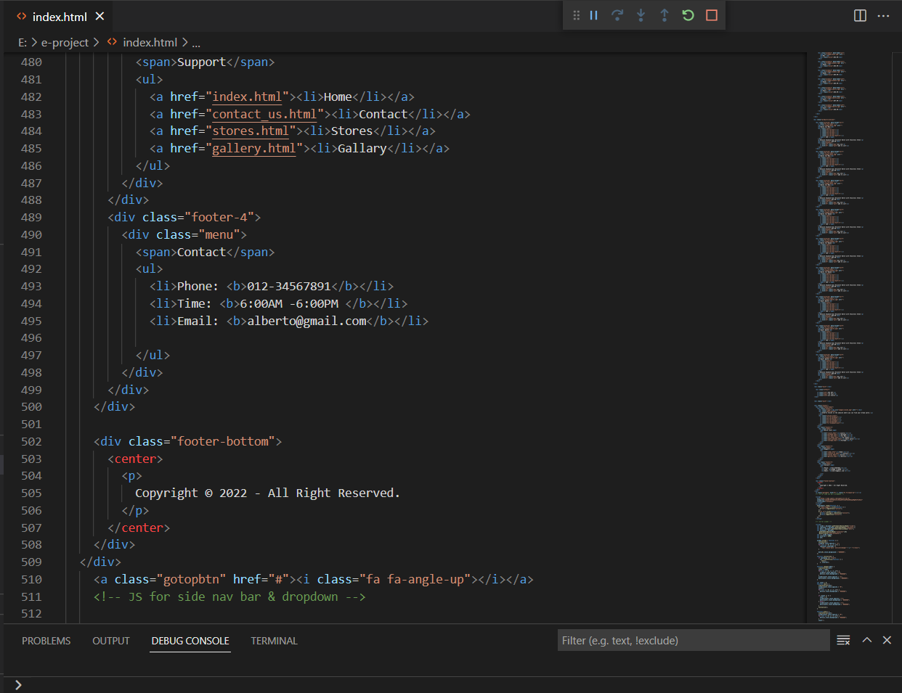

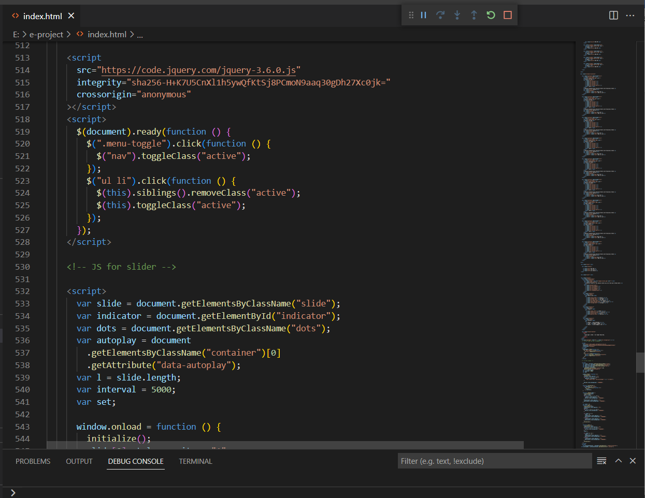

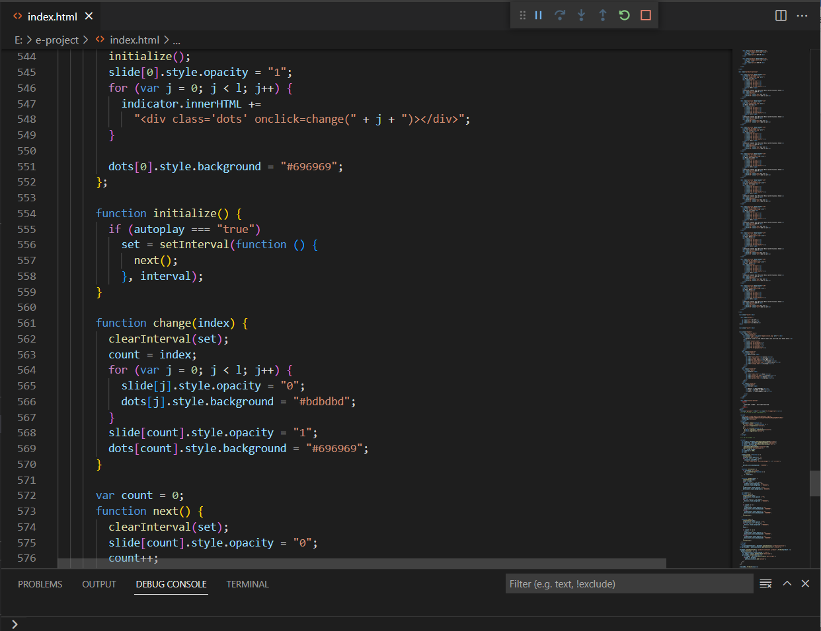

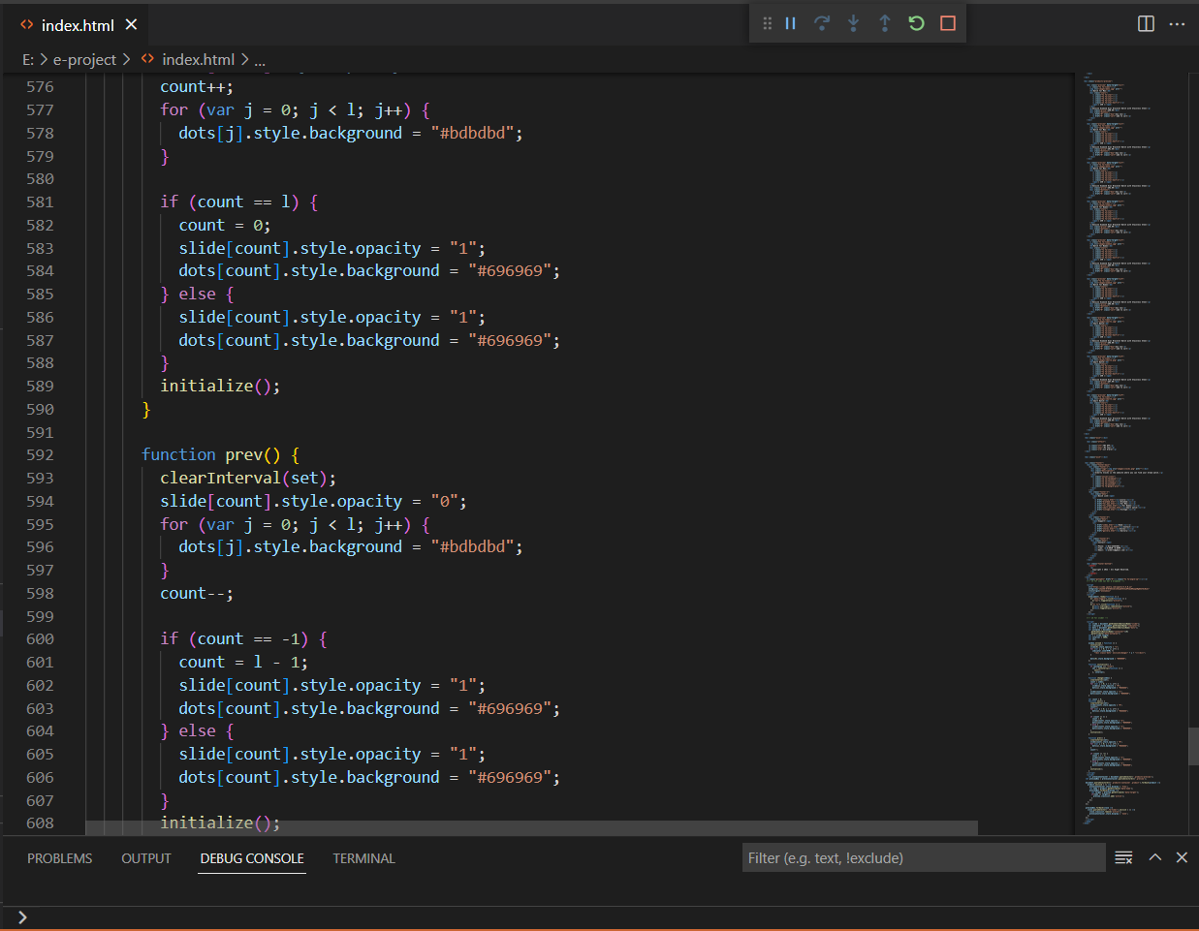

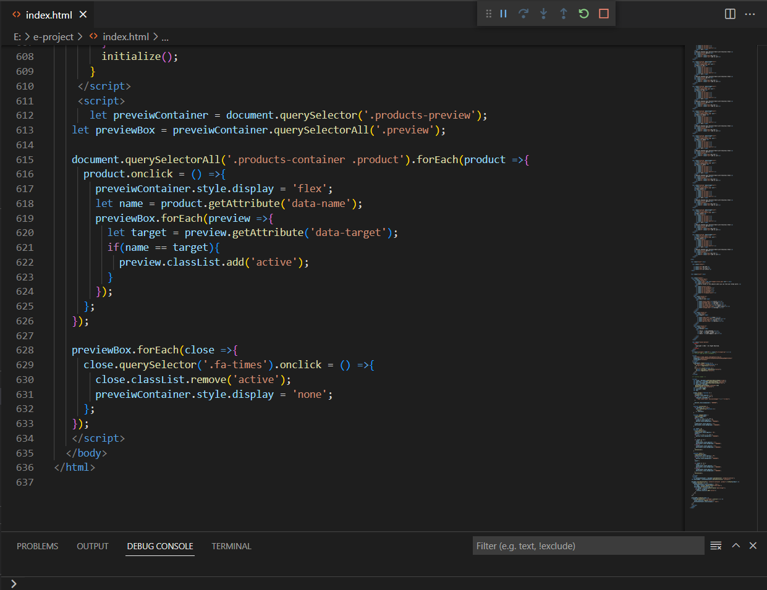

**(Product)**

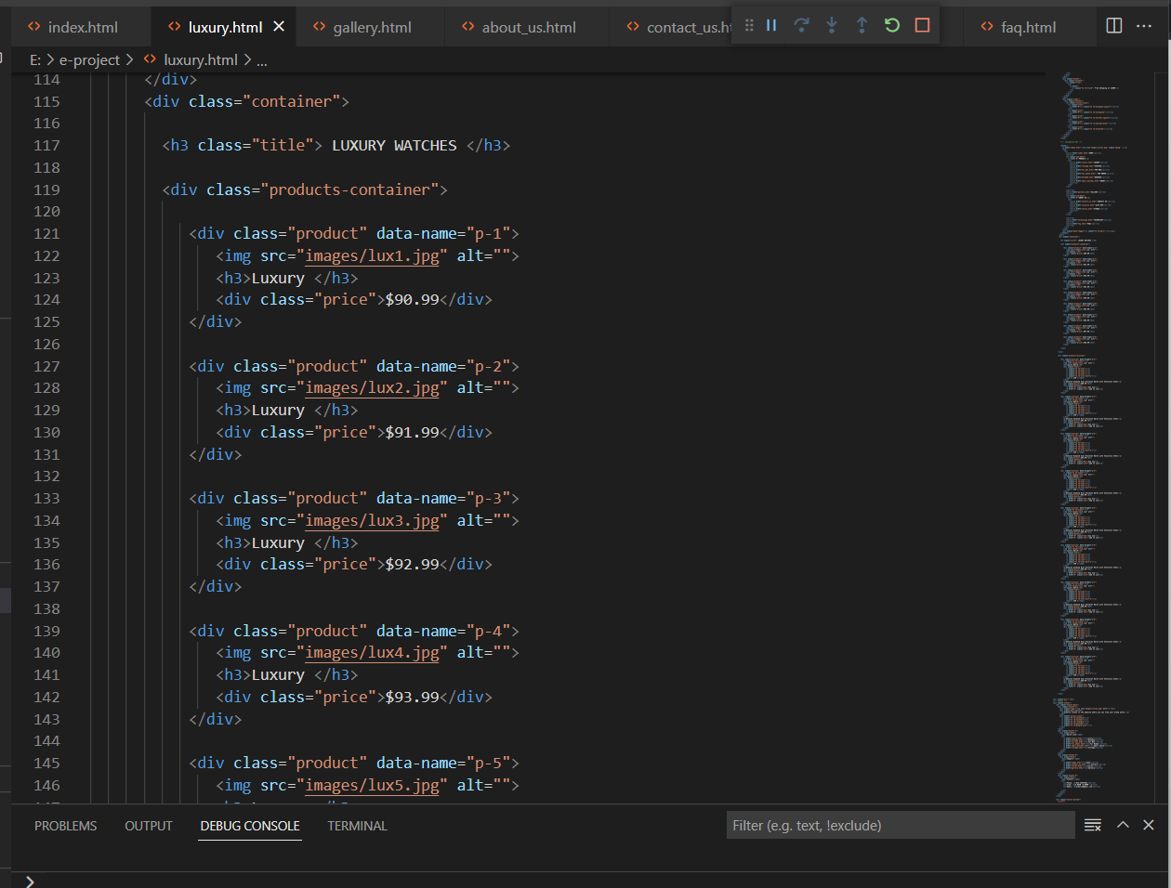

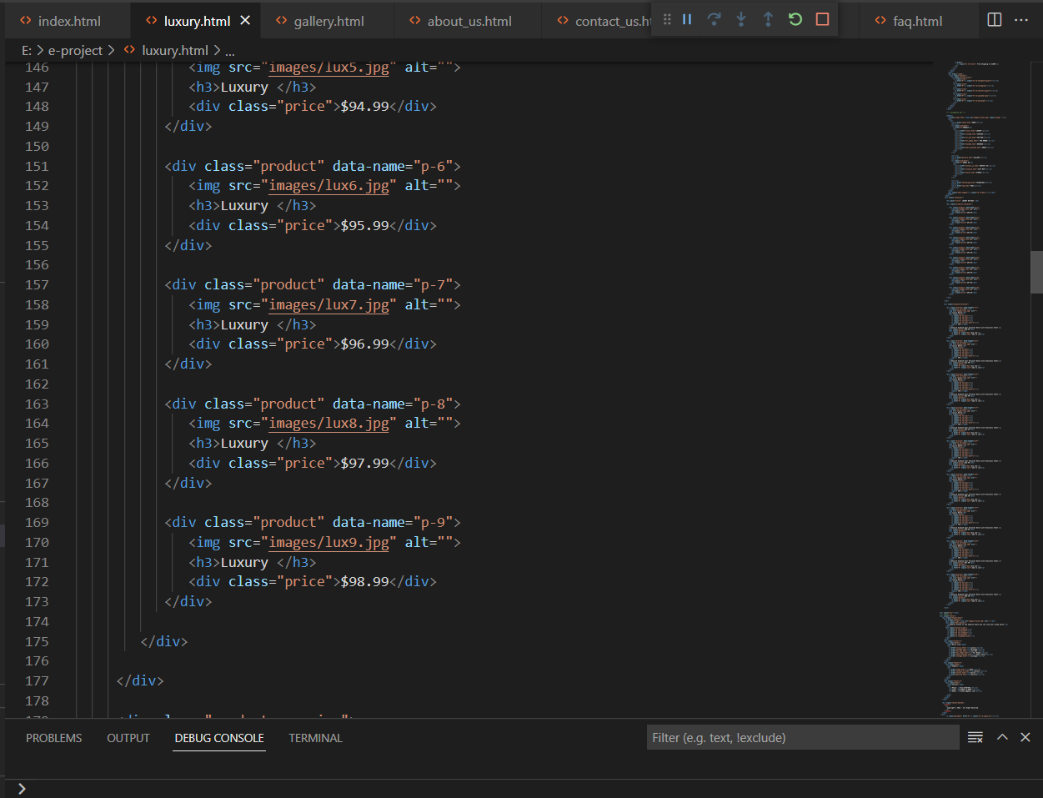

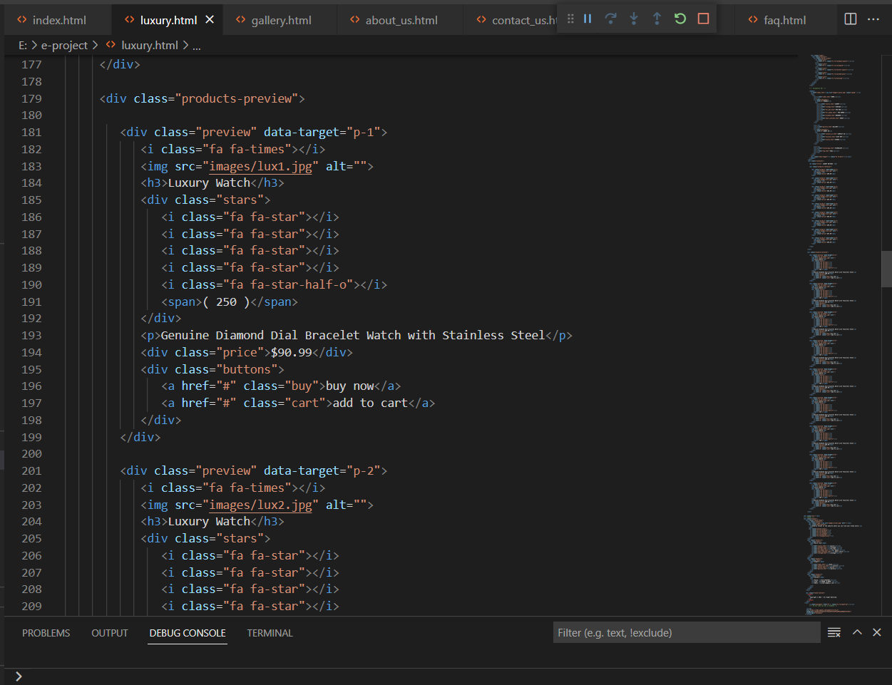

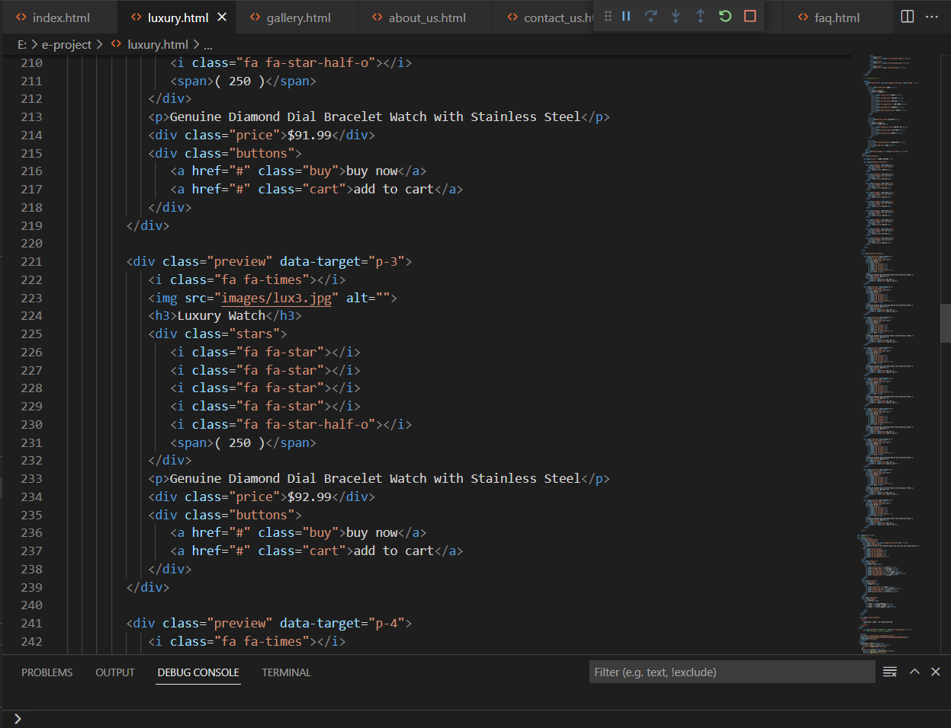

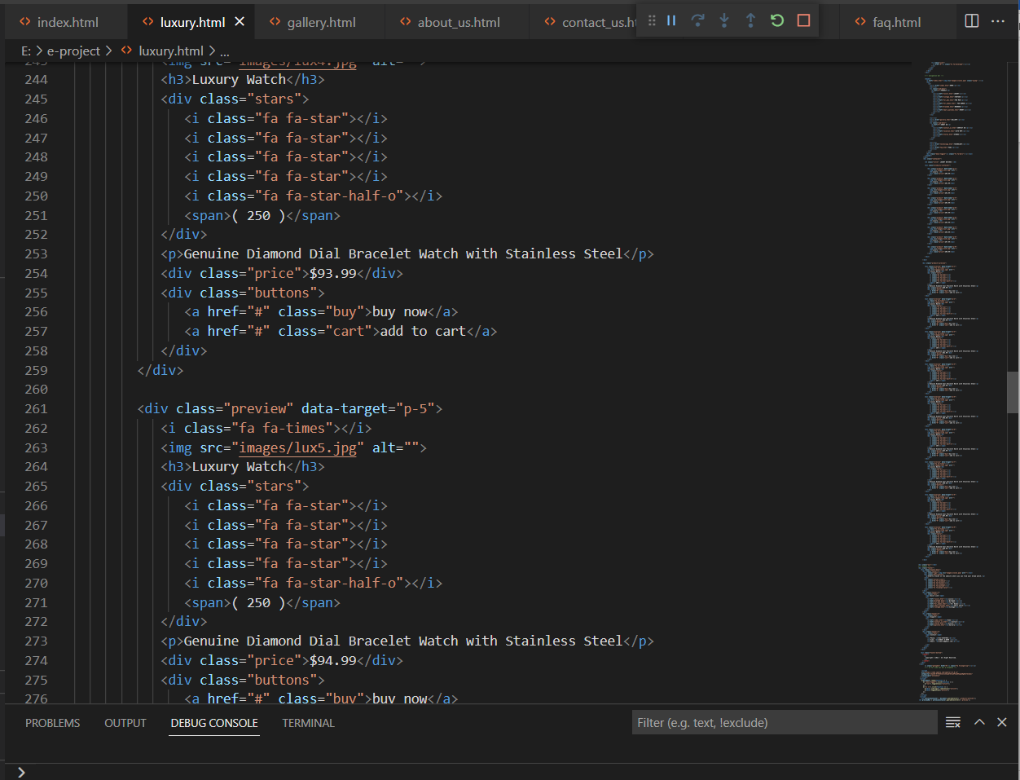

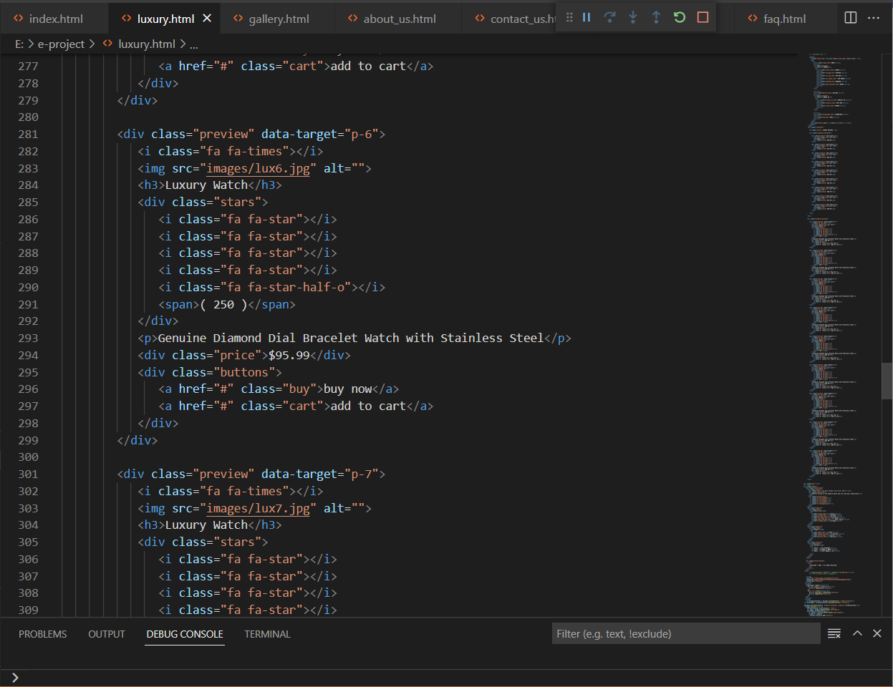

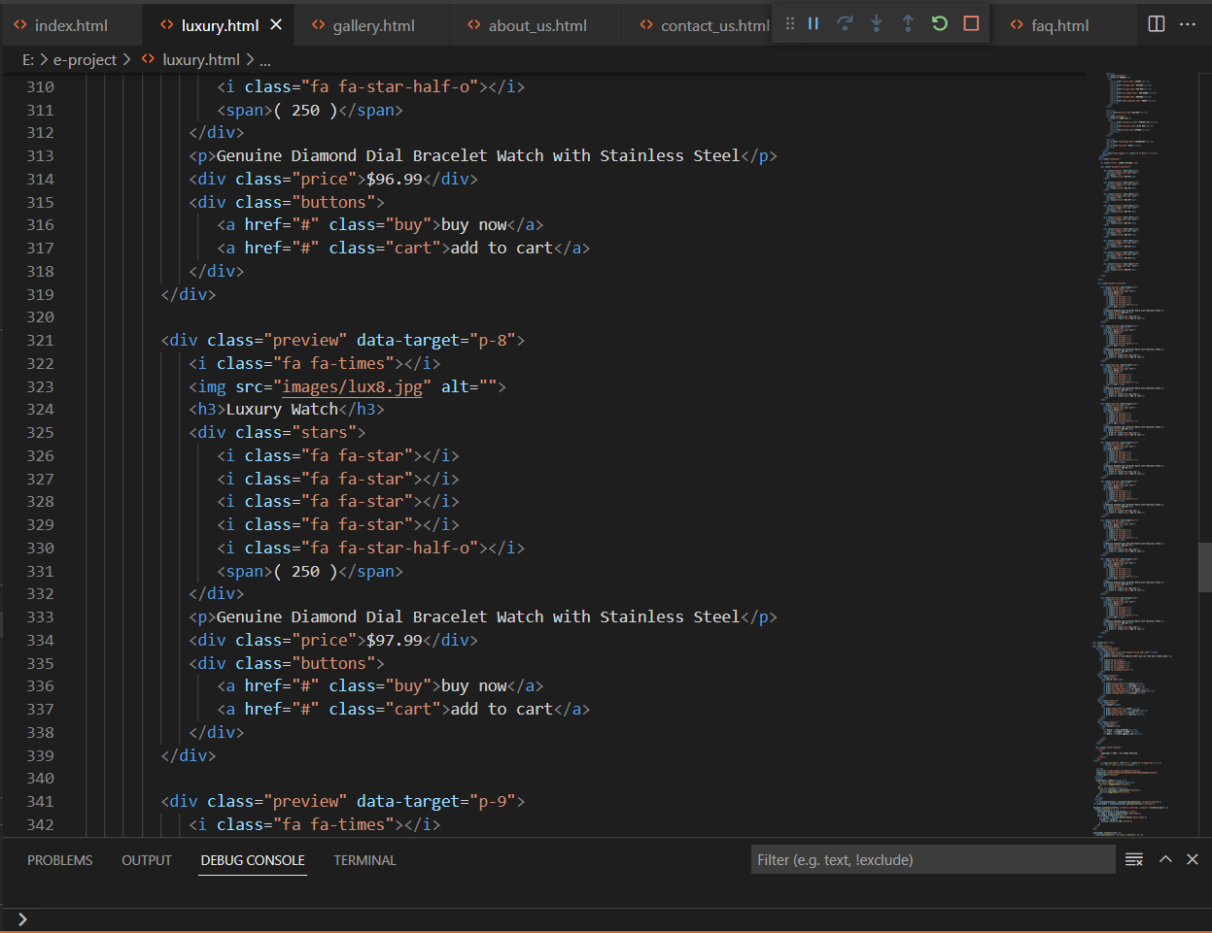

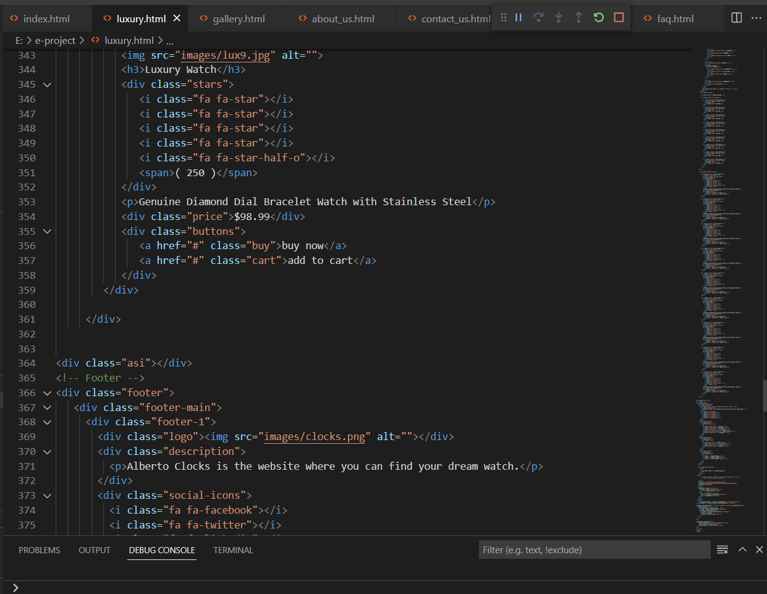

**(Gallery)**

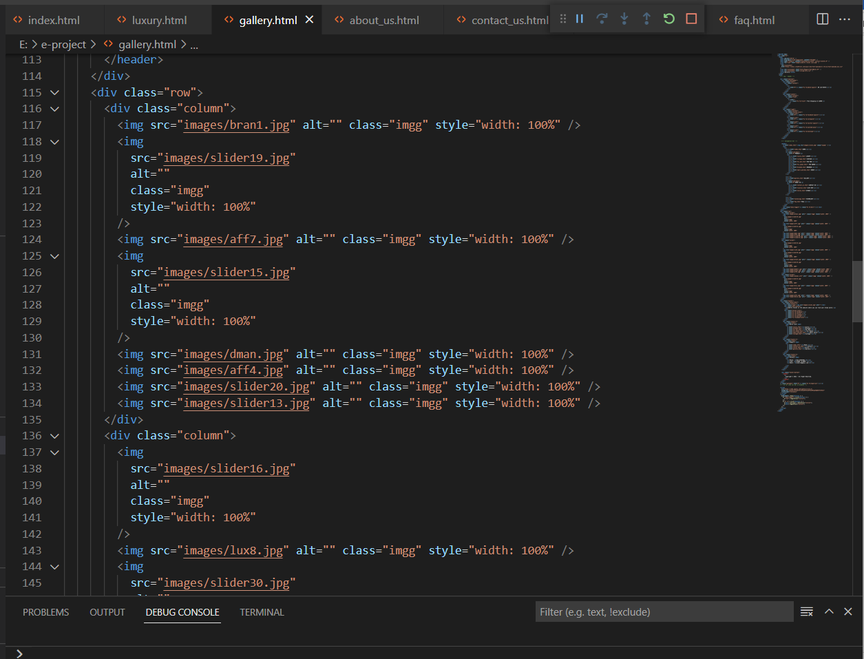

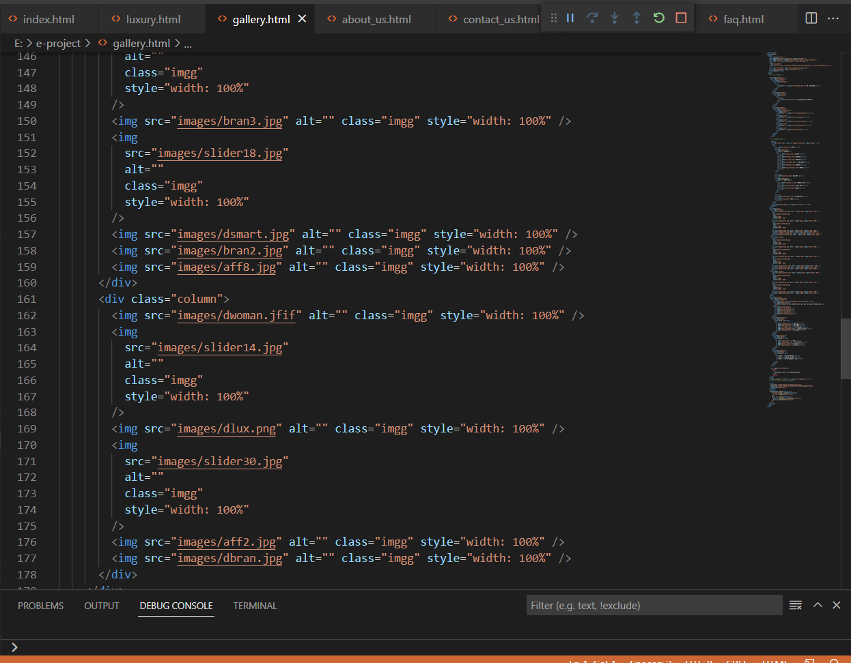

**(About us contact)**

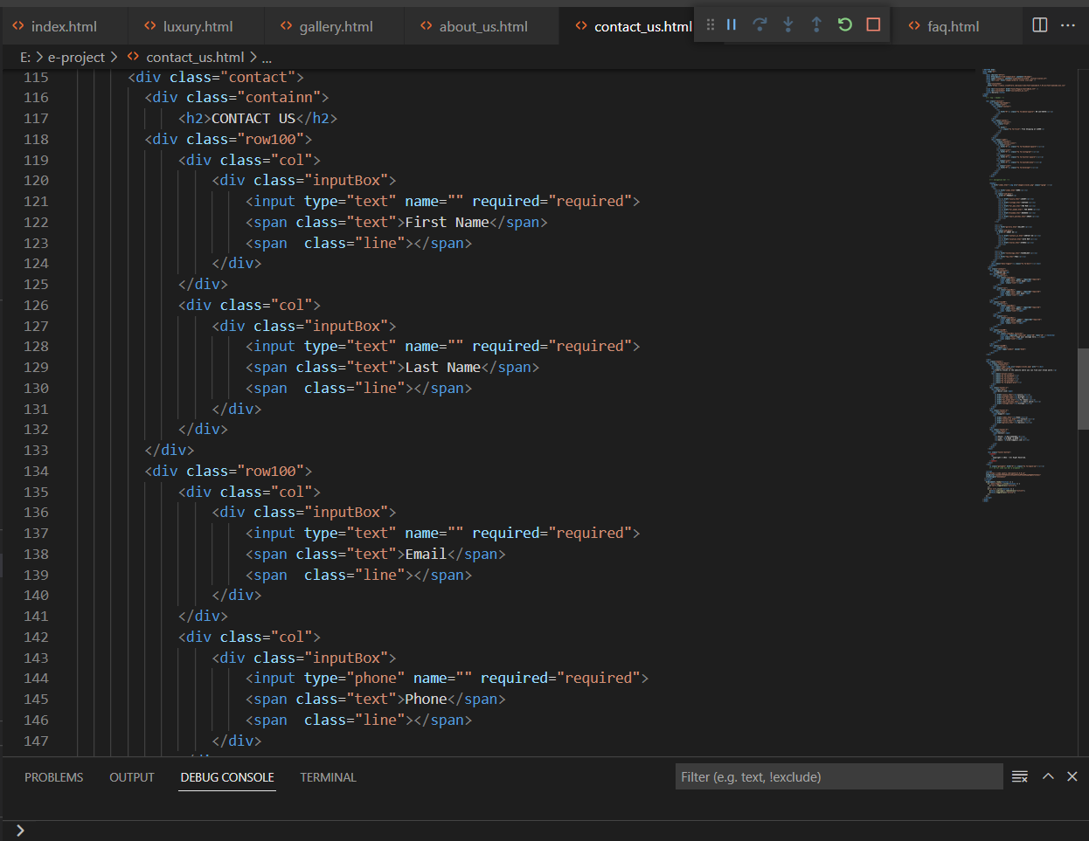

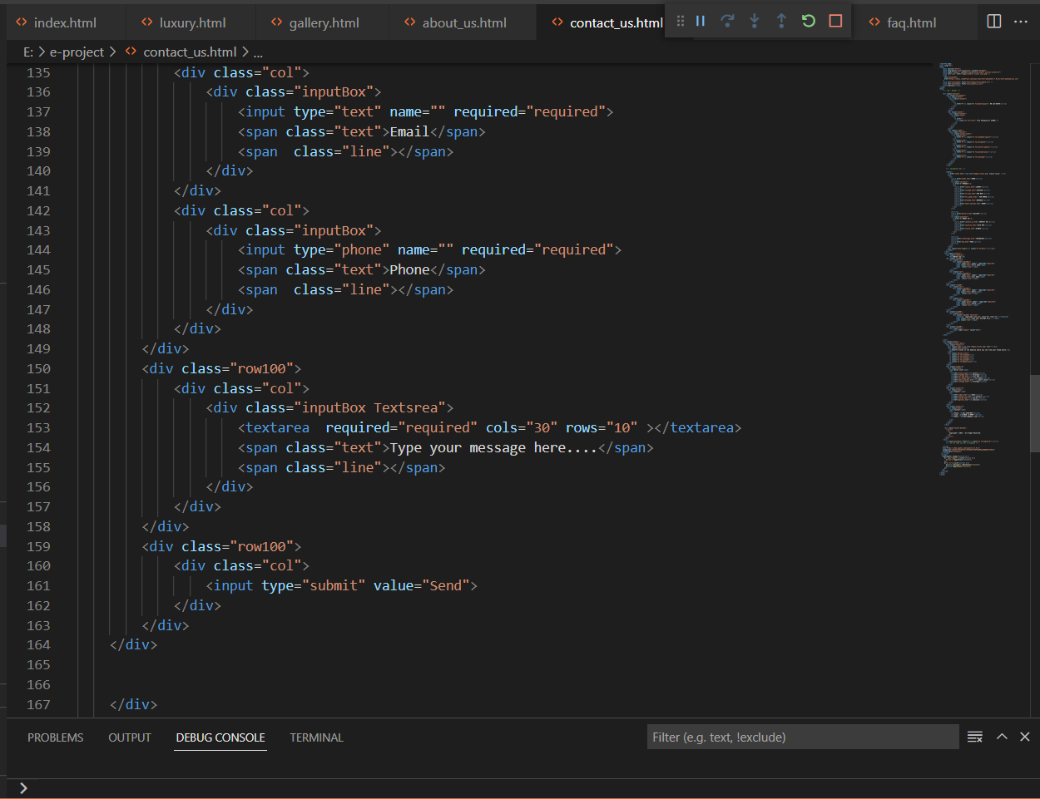

(**About us sitemap)**

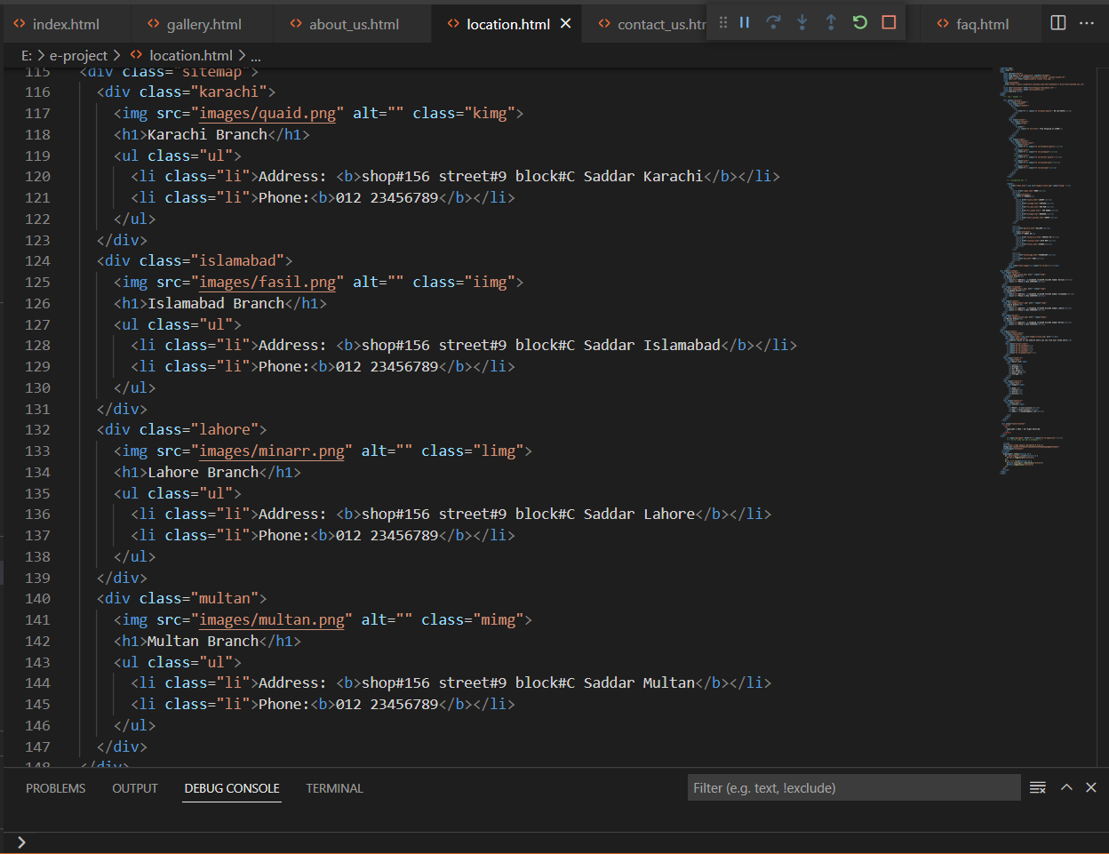

**(About us stores)**

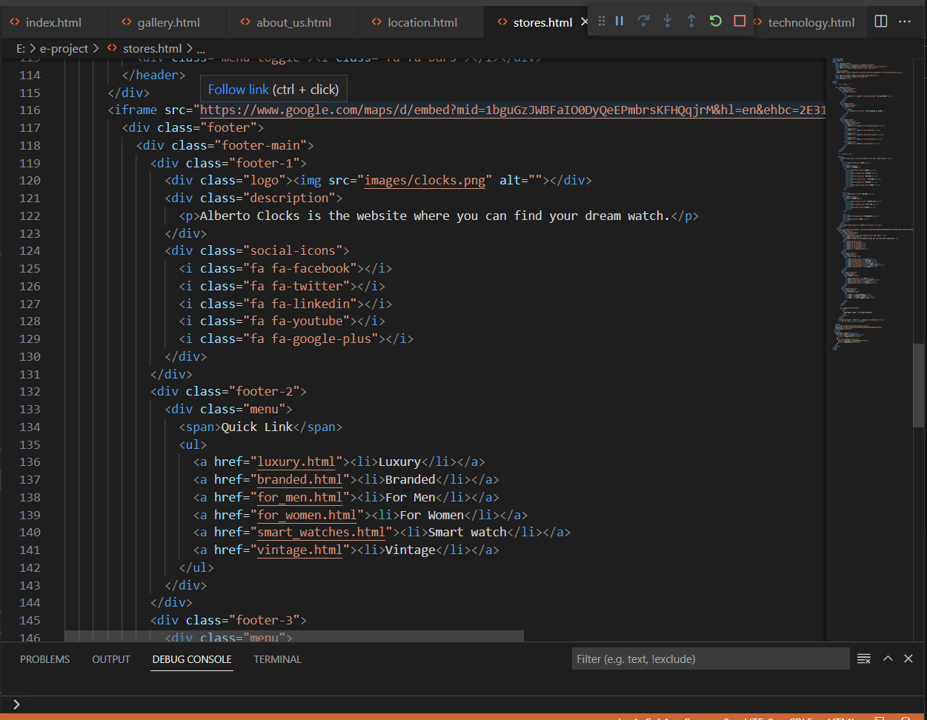

**(Technology)**

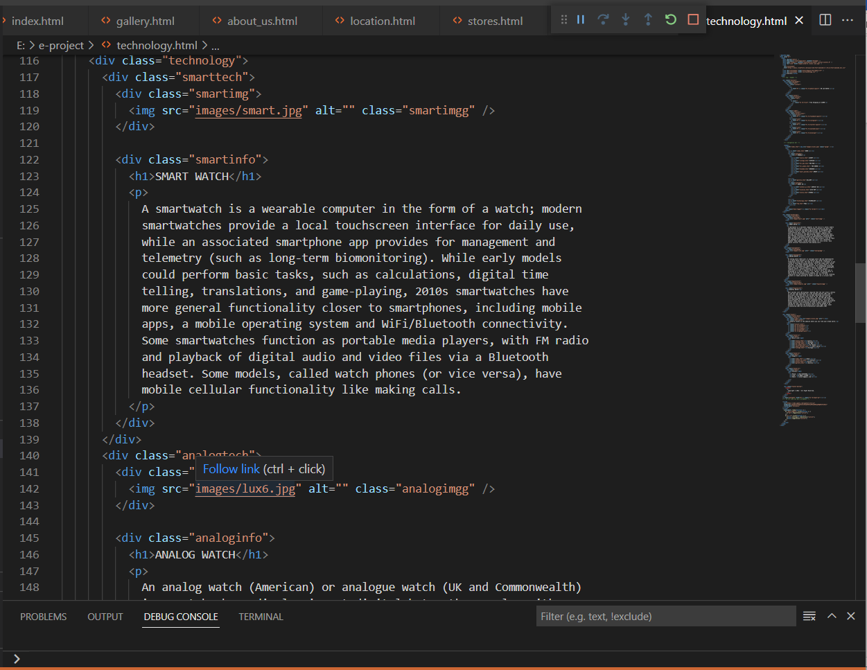

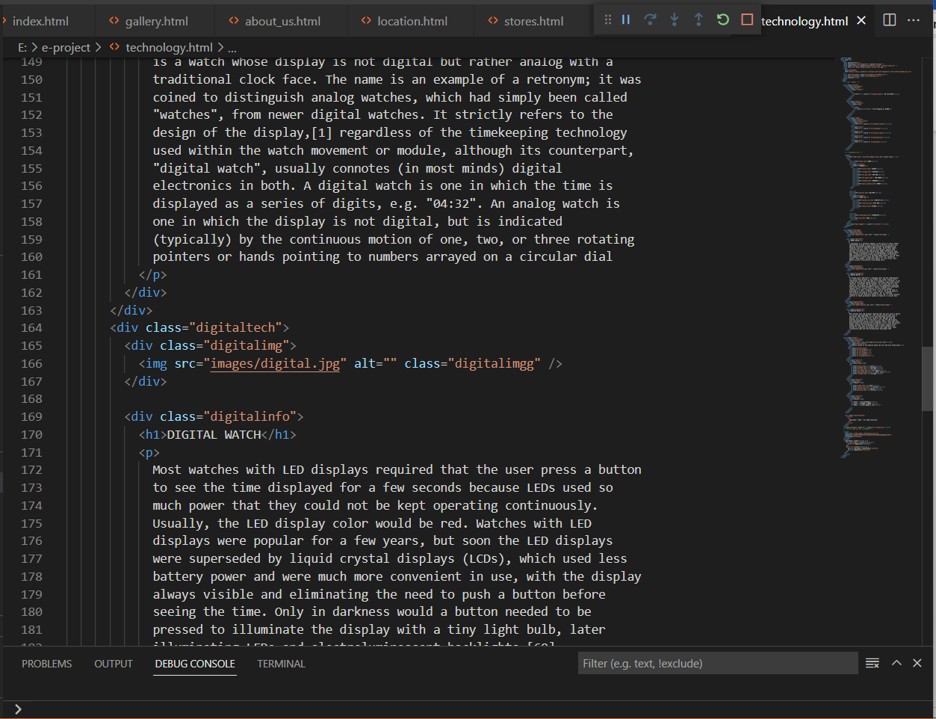

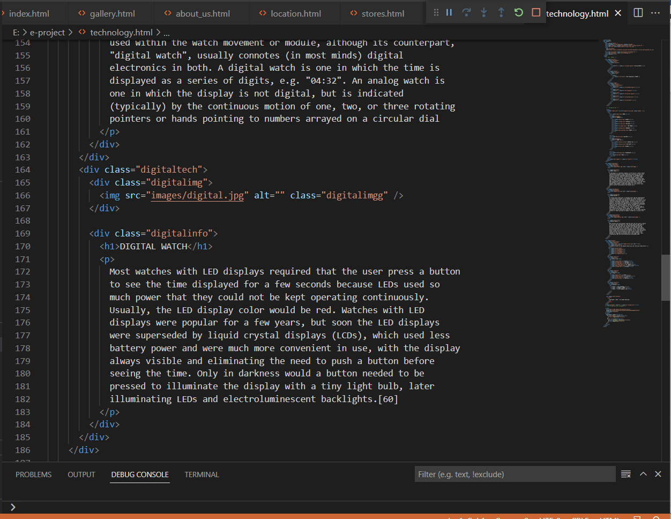

**(FAQs)**

